3 6 9 a i . B i z

Van Sale

User Guide
Everything the app can do — from your first login to the very last button.
App version 1.4.0

How to read this guide
You don't have to read this front to back. If you're new, start at the beginning and work through "Getting started" — that covers logging in and finding your way around. After that, jump to whatever you actually need using the contents list on the next page.
Every screen in the app has its own short section here. Each one tells you what the screen is for, how to open it from the Home screen, and the exact taps to get the job done. Where it helps, there's a real screenshot so you know you're in the right place.
A couple of things before you start
- Your Home screen might look shorter than the screenshots here. That's deliberate — your admin can hide screens you don't need, so don't worry if a tile in this guide isn't on your phone.
- Amounts, names and shops in the screenshots are sample data. Yours will show your own stock, customers and prices.
- Anything marked "for administrators only" needs the admin login. If that's not you, you can skip those parts.
PART 1 · GETTING STARTED
Welcome
Van Sale is the app you use to run the shop day to day. It's a till, a stock book, a purchase ledger, a customer list and an accounts folder rolled into one — all on a single phone or tablet.
On a normal day you'll mostly live in two screens: the POS register for ringing up sales, and Orders for looking back at what you've sold. But there's a lot more under the surface — recording what you buy from suppliers, keeping an eye on stock, logging expenses, sending invoices and checking how the shop is doing. This guide walks through all of it.
Who this is for
- Cashiers — open the register, ring up sales, take payment, print the receipt.
- Managers — check the day's takings, watch stock, log purchases and expenses, look after customers.
- Administrators — set up staff logins, decide who can see what, and manage the banners and accounts.
The app runs on top of an Odoo back office, so anything you do here shows up there too, and the other way around. You don't need to know any of that to use it — it just means the numbers always line up.
Opening the app the first time
Tap the Van Sale icon. You'll see the logo for a second or two while everything loads, then one of two things happens: if you've signed in before on this device, you go straight to the Home screen; if not, the login screen opens.
Setting up a brand-new device
On a fresh device the app first asks you to point it at your shop's system. The Device Setup screen walks you through three boxes from top to bottom: the Server URL (the address of your shop's server, e.g. http://10.48.96.175:8069), the Database (once the URL is in, the list of databases loads and you pick yours), and the Admin Credentials (an admin username and password). Tap Configure Device and you're linked.
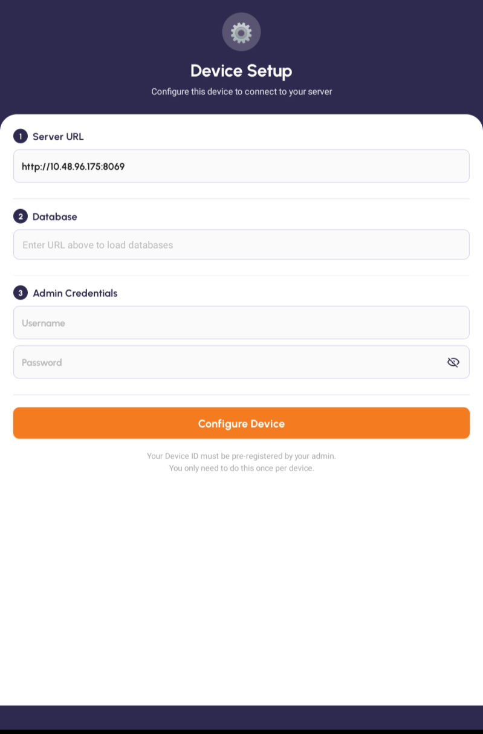
Device Setup — fill in the server, database and admin login, then tap Configure Device.

Your device has to be registered by your admin beforehand, and you only ever do this once per device. After that the app remembers the connection. (Some setups let you scan a setup QR code instead of typing the server details — your admin will tell you if that's how yours works.)
The camera permission
The first time round, your phone asks whether the app can use the camera. Tap Allow. The camera is used for scanning setup and product barcodes and for photographing customer ID documents. If you tap Deny by mistake you can switch it back on later in your phone's settings.
Logging in
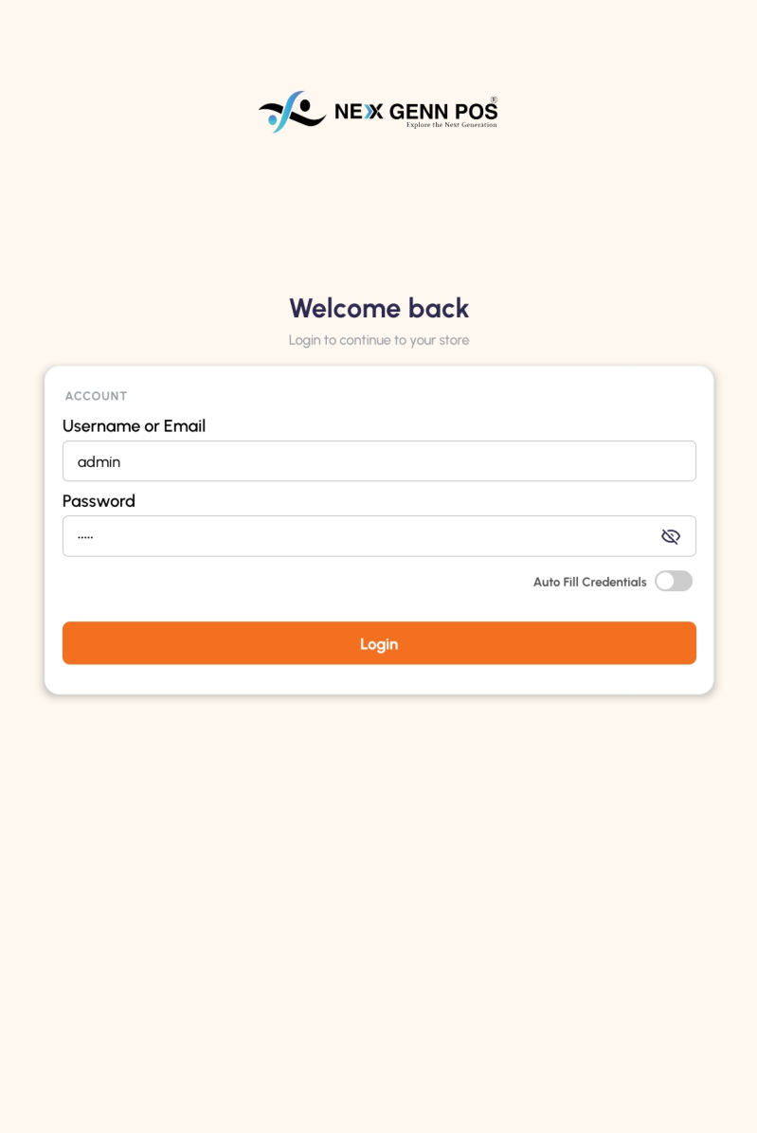
The login screen — your username is usually your email; tap the eye to check your password.

What it's for
This is the front door. Under the "Welcome back" heading there's an Account card with two boxes — Username or Email and Password. Type the details your admin set up for you and the rest of the app unlocks. The app remembers you afterwards, so you won't have to do this every time — only after you log out.
Step by step
- Open the app. If you're not already signed in, the "Welcome back" login screen is waiting for you.
- Tap the Username or Email box and type your username. For most people that's their email address.
- Tap the Password box and type your password — the letters stay hidden. Tap the eye icon on the right if you want to check what you've typed.
- Tap the orange Login button.
- If it's right, the Home screen opens. If it isn't, a small message pops up at the bottom (something like "Invalid details"). Check for typos and try again.
Auto Fill Credentials
Just above the Login button there's an Auto Fill Credentials switch. Turn it on and the app remembers your login and fills both boxes for you next time, so you only tap Login. It's handy on your own device — leave it off on a shared one so the next person can't sign in as you.
Good to know
- Forgot your username or password? Your admin can look it up or reset it — there's no self-service reset.
- Both boxes have to be filled in. Leave one blank and the app won't let you continue.
- Each person should sign in with their own login. The shop's reports track who rang up each sale, so sharing one account muddles the figures.
The Home screen
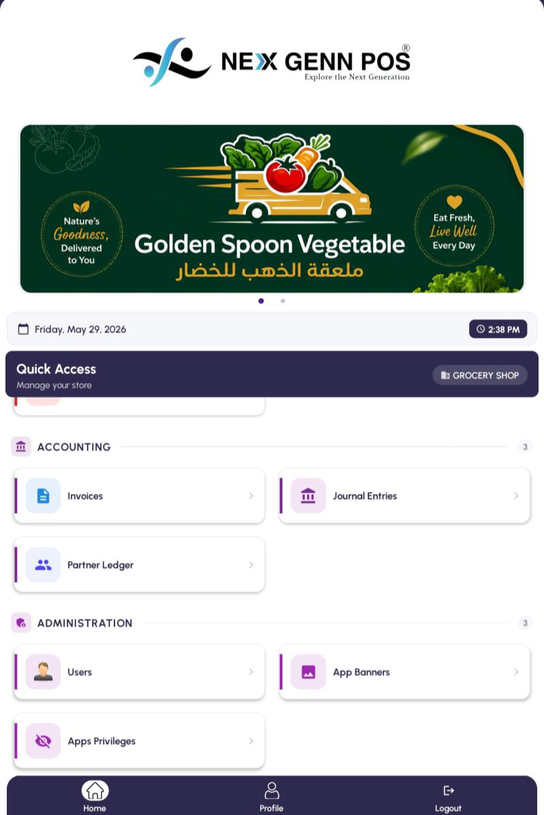
The Home screen — tiles are grouped into sections; the bar at the bottom is always there.

What it's for
Home is your launch pad. Everything in the app is one tap away from here. The tiles are sorted into sections — Sales & POS, Inventory, Easy Purchase, Contacts, Finance, Accounting and Administration — so you're not hunting through a long list.
The bits around the tiles
Across the top there's a banner that slides between any promotions your admin has set up, with today's date and the time just below it. The purple "Quick Access" strip shows which shop you're working in. Then come the tiles.
The tiles, section by section
Tiles are grouped so you're not hunting through a long list. This is everything the app can show, though your own Home screen may be shorter — your admin can hide anything you don't need.
- Sales & POS — POS, Orders, Sales Report.
- Inventory — Products, Stock.
- Easy Purchase — Easy Purchase, Quick Return.
- Contacts — Customers, Customer ID Proofs.
- Finance — Expenses.
- Accounting — Invoices, Journal Entries, Partner Ledger.
- Administration — Users, App Banners, Apps Privileges, Invoice Settings, User Manual. These five are for administrators only; anyone else tapping them gets a short "Only administrators can access this feature" message.
One tile behaves differently from the rest: Journal Entries doesn't open a list straight away. It asks which set of books you want first — Sales, Purchases, Bank & Cash or Miscellaneous — and opens that one.
The bar at the bottom
Three buttons sit at the bottom of the screen wherever you are in the app:
- Home — jumps you back to this screen.
- Profile — shows your account details.
- Logout — signs you out (it asks first, so a stray tap won't catch you out).
Finding your way
- Look down the tiles — each one is a feature.
- Tap a tile to open it (POS, Orders, Products and so on).
- To come back, tap the arrow at the top-left or the Home button at the bottom.
- Drag the screen down to refresh — handy if a banner or a tile has just been changed for you.
Good to know
- Missing a tile you expected? Your admin has probably hidden it for your login. Ask them to switch it back on under App Privileges.
- The little number next to each section heading tells you how many tiles are in it.
- Orders Analysis isn't a tile. It lives inside Sales Report — open the report and tap the Orders card at the top.
- Every tile except Orders and Apps Privileges can be hidden for a particular person. Hide all the tiles in a section and the whole section disappears from their Home screen.
PART 2 · SELLING (POS & ORDERS)
POS — the register
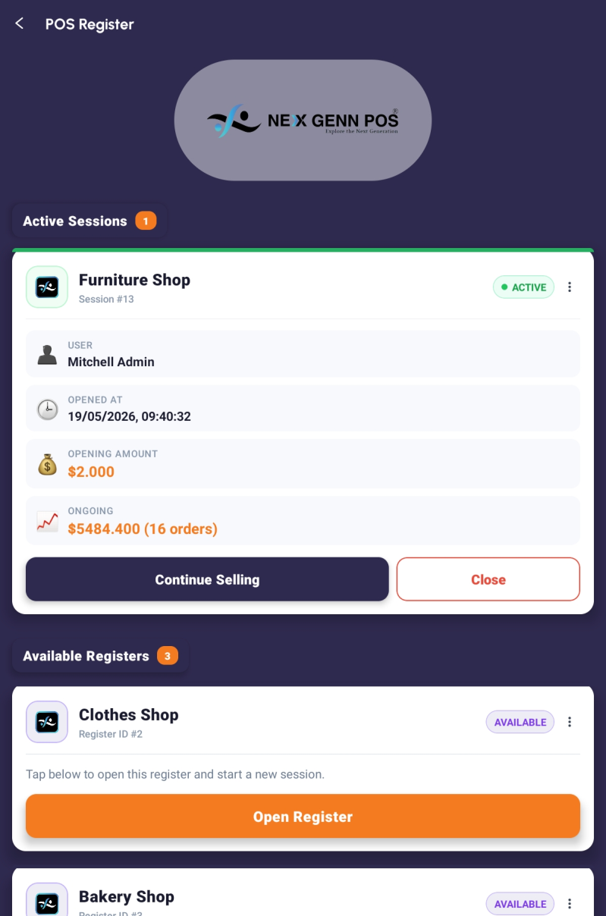
The POS register list — open a register to start selling.

What it's for
POS (Point of Sale) is where the actual selling happens. You open a register, add what the customer is buying, take their money and hand over a receipt. It's the screen you'll use more than any other.
Each register is tied to a shop or counter. A register that's already running shows as an Active Session with its opening float and how much it has taken so far; one that's free shows as Available with an Open Register button.
How to get there
From the Home screen: Home → POS.
Opening a register
- Tap POS on the Home screen.
- If your register already has a green ACTIVE session, tap Continue Selling to carry on where you left off.
- If it's Available, tap Open Register.
- Type the cash you're starting the drawer with (your opening float) and confirm.
- The product screen opens and you're ready to sell.
Adding products to the basket
- Search by name in the box at the top, or tap a category chip to narrow the list.
- Tap a product to drop it in the basket. Tap again to add another, or use the quantity control to set the number.
- Keep going until everything's in.
- Tap the basket icon at the top-right (it shows how many items are in there) to review the order.
Checking the basket
- Look over every line. Use plus and minus to change a quantity, or the bin icon to drop a line.
- When it all looks right, tap Proceed to Payment.
Editing a line price
Some staff can change the price of a line right on the order — useful for a one-off deal or to fix a mistake. If that's switched on for you, tap the line's price and type the new one.
If you tap a price and nothing happens, that's not a bug: your admin has locked price editing for your login. Prices are then fixed at whatever the product is set to. (Admins control this under App Privileges — see that section.)
Pausing a sale
Need to step away mid-sale? Leave the basket and tap back. The order is kept as a Draft and you'll find it in Orders, ready to pick up again later.
Good to know
- Can't find a product? It probably hasn't been added yet. Pop into Products (or ask your manager) to create it, then come back.
- Closing the drawer at the end of the day is done from this same POS screen — tap Close on the active session and count the cash.
Taking payment and printing the receipt
What it's for
This is the last step of a sale. You pick how the customer is paying, enter the amount, and the app works out any change. You can also tie the sale to a customer and knock money off with a discount before you finish.
Step by step
- From the basket, tap Proceed to Payment.
- If you want the sale linked to someone, tap the customer field and search for them (or add a new customer on the spot).
- Once you've picked a customer, a signing box pops up — have the customer sign the Customer box, then sign the Cashier box yourself, and tap Done. You can re-sign any time from the payment screen.
- To give a discount, tap the Apply discount chip. Otherwise skip to choosing a payment method.
- In the discount popup, pick the type — Total discount takes it off the whole bill, Items discount takes it off each line — and the format, Percentage or Amount.
- Tap one of the preset values your shop has set up, or type your own, then confirm. The chip now shows the discount and a Discount line appears in the totals. Tap the chip again any time to change or clear it.
- Choose how they're paying — Cash, Card, Credit or Split Payment.
- Type the amount handed over on the keypad. The change due shows automatically.
- If the customer has an ID photo on file, a small preview appears so you can check it's them.
- Tap Validate / Complete Sale.
- As you tap Validate, the app records where the sale is taking place — it reads the device's location and saves the coordinates (and the place name) onto the order and the receipt. If location is switched off, or the app hasn't been given permission, you'll be asked to turn it on or allow access. If it still can't get a fix after a few tries, tap “Save without location” to finish the sale anyway.
- The receipt preview opens. Tap Print for a connected printer, or share it digitally. You're then dropped back at the product screen for the next customer.
Selling on credit
Credit lets a customer pay later — it's put on their account rather than collected now. You have to pick a customer first (the app won't let you take credit for an anonymous sale), since the balance has to go against someone. You can put the whole sale on credit, or take part of it now
(cash or card) and leave the rest on account. The outstanding amount then shows up against that customer in the Partner Ledger and on their invoices.
Split Payment
Use Split Payment when someone pays part Cash and part Card in the same sale. Tap Split Payment, put an amount against Cash and an amount against Card, and the two have to add up to the total before you can confirm. (Paying part now and the rest later is Credit, above — not Split.)
Money the customer still owes
If the customer you've picked still owes money from earlier sales, an amber Previous Due card appears under the total on the payment screen. It's there so you can ask for it before you take today's money — nothing is added to this sale automatically.
The same figure carries onto the receipt. Whenever there's an outstanding balance, three extra rows print near the totals: Previous Due (what they owed before today), This Invoice (what this sale comes to) and Total Due (the two added together). If the customer is square with you, none of it prints at all.
The figure is that customer's open balance with your company, with this sale's own invoice left out so it isn't counted twice. It always matches what you'd see against them in the Partner Ledger.
Good to know
- The change-due figure updates as you type — no mental arithmetic needed.
- Cash and the Cash slot of a split both need a customer selected, or the app will send you back to choose one.
- A finished sale turns into an order you can reopen and reprint later from the Orders screen.
Customer and cashier signatures
When a customer is attached to the sale, the app asks for two quick signatures — one from the customer and one from you — so the receipt carries a record that you both agreed the sale.
- Pick the customer first. The signing box pops up on its own with the customer's name across the top.
- Tap the Customer box and sign, then the Cashier box and sign — each one opens a signing pad.
- On the pad you can switch between Pen and Eraser, make the line thicker or thinner, change the colour, or tap Clear to start again. Tap Save to keep it, or Cancel to back out.
- Both signatures then sit on the payment screen just above the Validate button — tap either one to sign again.
- Finish the sale as normal. The signatures are saved with the order and print on the receipt — in the preview, the PDF you download or share, and the thermal print — down near the totals.
- Reopen the order later from Orders and the signatures are still there on the reprint.
- Thermal printers only print in black, so a coloured signature comes out black on a printed ticket — the colour still shows in the on-screen and PDF copies.
Choosing the receipt size
What it's for
Shops print on all sorts of paper — a narrow till roll at the counter, a wider one in the back, a full sheet for a customer who wants a proper invoice. So whenever you ask for a receipt, the app checks what you're printing on and re-flows the receipt to fit.
How to get there
It comes up on its own: tap Preview, Download or Print, either on the receipt at the end of a sale or on an old order you've reopened from Orders.
Step by step
- Finish a sale, or open an old order from Orders.
- Tap Preview, Download or Print.
- The Choose receipt size box opens with the sizes your shop has set up — usually 2 inch, 3 inch, 3.5 inch, 4 inch, A5 and A4.
- One of them may carry a purple Default badge. That's the size your admin has picked as the shop's normal one.
- If none of them fits, tap Custom width (mm) at the bottom, type the width you want and tap Use this size. It prints as one long continuous page at that width.
- The receipt re-flows to the size you chose and whatever you asked for — preview, download or print — carries on.
When the app doesn't ask
Your admin can set one size as the shop's default and tell the app to just use it. When that's switched on, Preview, Download and Print go straight through and you never see the box. If you'd rather be asked each time, that's the Use Default Receipt Size switch under Invoice Settings — see that section.
Good to know
- Every size prints at full size on a single page now. Receipts no longer come out shrunk or split across two sheets.
- The sizes on offer are the ones set up under Invoice Settings → Receipt Paper Sizes, so they can be different from one shop to the next.
- Change the setting in Invoice Settings and the till picks it up straight away — there's no need to close and reopen the app.
Takeout & delivery orders
Takeout & Delivery is a fuller version of the basket, built for orders that aren't a quick over- the-counter sale. You get a proper line-by-line list with a few more controls on each item.
On every line you can change the quantity, add a note the customer will see, and (if you're allowed) edit the price. There's a discount you can apply per line or across the whole order, an order-level note, and a way to tick several lines at once and remove them together. Pick the customer at the top, choose a payment method at the bottom, and the running total sits at the foot of the screen.
Good to know
- The per-line price box follows the same rule as POS — if your admin has locked price editing, the price shows but you can't change it.
- Use the multi-select tick boxes when a customer changes their mind about several items — quicker than deleting them one by one.
Orders
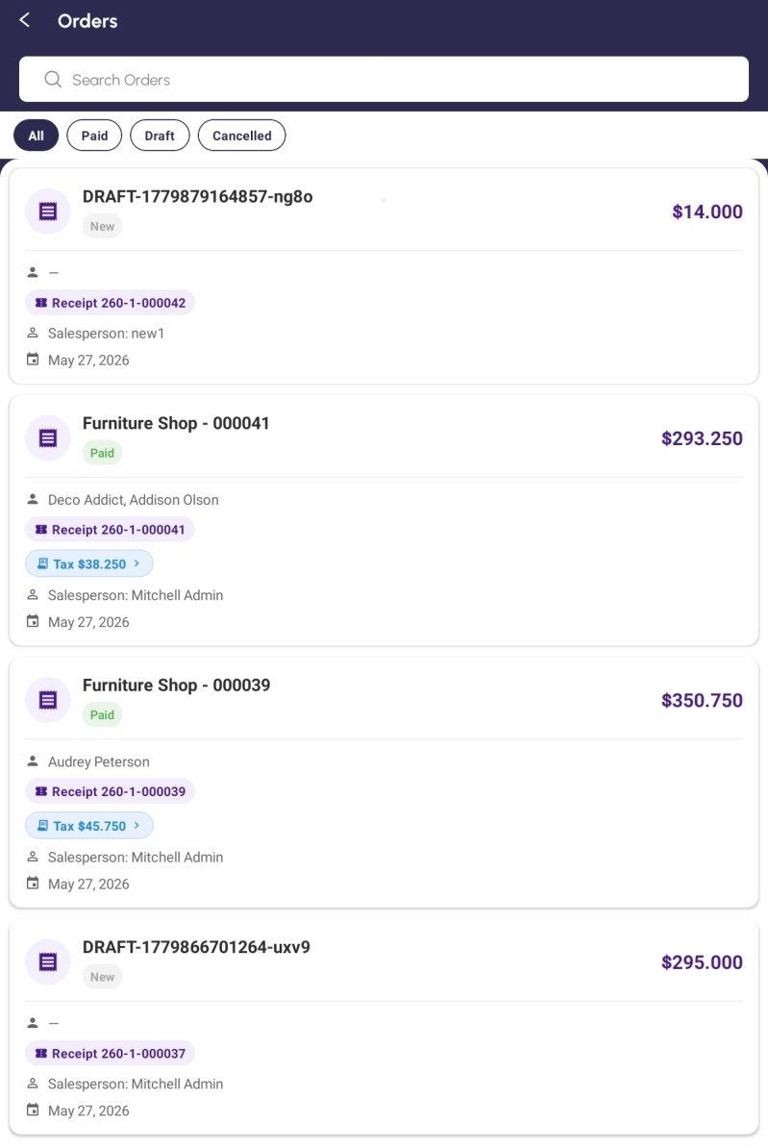
Orders — every sale, filterable by status, searchable, tap any one to open it.

What it's for
Orders is the history of everything sold through POS. Search by order number, customer or date, and filter by status. Drafts can be reopened and finished; anything completed can be reprinted. Tap a tax chip on a row to see exactly how the tax breaks down.
How to get there
From the Home screen: Home → Orders.
Step by step
- Tap Orders on the Home screen.
- The newest sales sit at the top.
- Use the chips along the top — All, Paid, Draft, Cancelled — to show just one kind.
- Search by order number, customer name or date in the box.
- Tap any row to open the full order and receipt.
- If it's a Draft, a Resume button loads those items back into the basket so you can finish the sale.
- From an open order you can print or share the receipt again, edit a draft, mark it paid, or turn it into an invoice.
Good to know
- The coloured status word tells you at a glance: grey is a draft, green is paid, blue is invoiced, red is cancelled.
- Drag the list down to pull in the latest sales.
- Tap a blue Tax chip to open the per-line tax breakdown.
Returning products to a customer
What it's for
When a customer brings something back, you don't cancel the original sale — you raise a return against it. The app builds a refund order from the sale you pick, and you pay the money back out through the register just like a normal sale, only in reverse. Everything stays linked, so the books and the stock both stay right.
You can send back everything they bought, or just part of it.
How to get there
From the Home screen: Home → Orders, then open the paid order you're returning against.
Step by step
- Open Orders and tap the sale the customer is bringing back.
- Tap the red Return Products chip. (It only shows on a paid sale that hasn't already been refunded.)
- If your register is closed, a message tells you to open a session in the POS first. Open it and come back.
- Confirm, and the app creates a refund order and drops you into the register with it loaded.
- For a full return, leave the quantities as they are. To return only some of it, change the quantity on each line to what's actually coming back, and take the rest off.
- Tap Payment and pay the money back the same way they paid you.
- Print or share the refund receipt in the usual way.
Finding a return later
Refund orders sit in the Orders list alongside everything else, with a red REFUND badge next to the status so you can spot them. Open one and you'll see the same badge plus a Refunded from … link that takes you back to the sale it came from. Tapping a refund order in the list opens it ready for payment rather than for editing.
Good to know
- Tax on a return is whatever was actually charged on the original sale, scaled to the quantity coming back — so a part return refunds exactly the right share of the tax.
- There's a Payment Reference box on the payment screen if you want to record a cheque number or a card reference against the refund. It's optional.
- Stock goes back up as soon as the return is paid out.
Sales Report
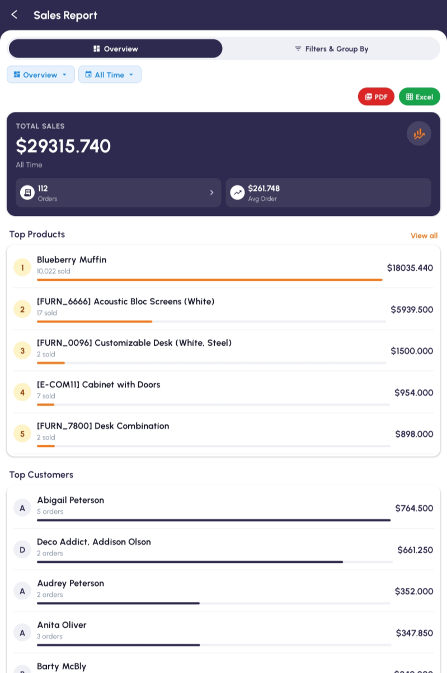
Sales Report — total takings, best products, best customers, all in one place.

What it's for
Sales Report is the shop's scoreboard. It shows total sales, how many orders, the average order value, your best-selling products, your top customers, the split between payment methods, and a profit-and-loss view. Pick a period — Today, 7 days, 30 days, All time, or your own dates — and export the lot to PDF or Excel.
How to get there
From the Home screen: Home → Sales Report.
Step by step
- Tap Sales Report on the Home screen.
- It opens on Overview showing today by default.
- Tap the period button (Today / 7 days / 30 days / All time) to change the range, or Custom for your own From and To dates.
- Switch tabs with the Filters & Group By control to move between Overview, Top Products, Top Customers, Payments and Profit & Loss.
- Top Products shows what sold most by quantity and by money; Top Customers shows who spent most.
- Payments shows the share of takings across the methods you use — cash, card and credit.
- Profit & Loss shows what's left after expenses come out.
- To export, tap PDF or Excel at the top and the file is saved or shared.
Good to know
- Drag down to refresh the numbers.
- The Profit & Loss figure uses the real expenses you've logged — keep Expenses up to date or it'll be off.
Orders Analysis
Orders Analysis turns your sales into a picture. Choose a period — today, this week, month, year, or your own dates — and you get a bar chart of orders per day plus headline numbers: total orders, total revenue, average order value, and how many were paid.
It's the quick "how are we doing" glance, where Sales Report is the detailed dig.
How to get there
Orders Analysis isn't a tile on the Home screen. Open Sales Report and tap the Orders card in the row of figures at the top — that's what opens it.
Good to know
- Status colours match the rest of the app: green for paid or posted, blue for invoiced, red for cancelled, grey for draft.
PART 3 · INVENTORY
Products
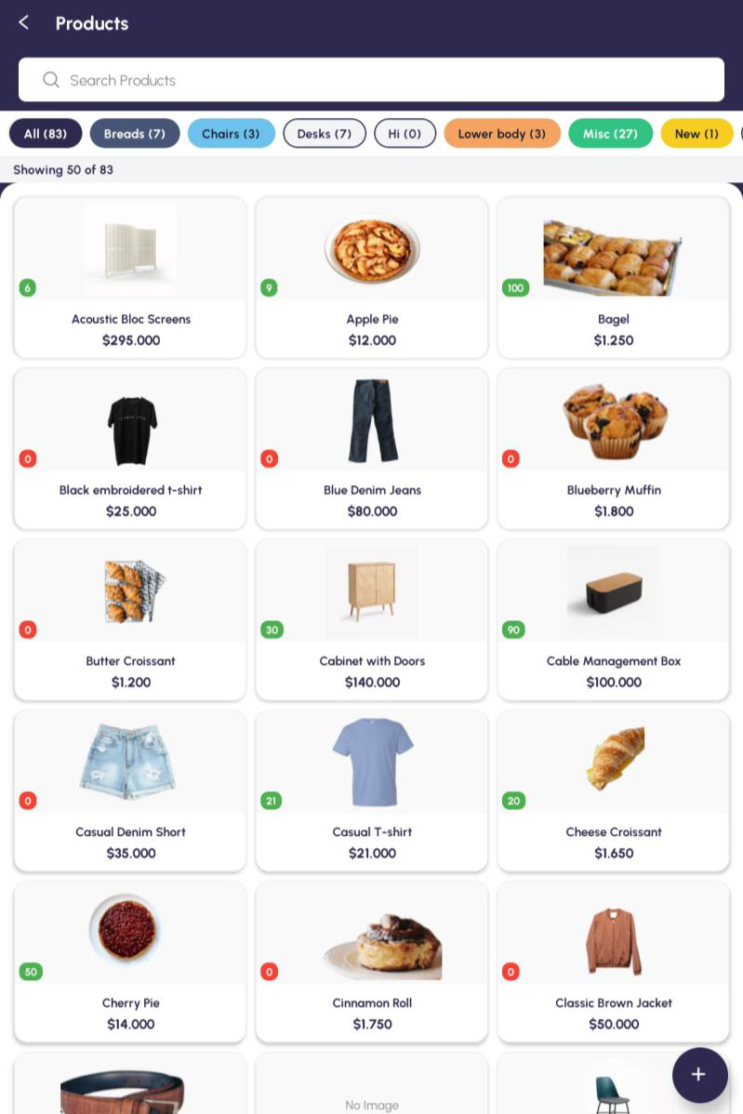
Products — your whole catalogue, searchable and filterable by category.

What it's for
Products is the full list of what the shop sells. Browse it, search it, filter by category, open any item to see its price, picture and details, and add new products. Anything you create here is ready to sell in POS straight away.
How to get there
From the Home screen: Home → Products.
Step by step
- Tap Products on the Home screen.
- Scroll the tiles, or search by name in the box.
- Tap a category chip (Breads, Chairs, Misc and so on) to filter.
- The grey strip under the chips tells you what you're looking at — Showing 12 of 340. At the right-hand end of it, Show Archived swaps the list for products that have been archived instead of deleted; tap Show Active to come back.
- Tap any product to see its details — picture, price, stock on hand, description.
- To add a new product, tap the round + button at the bottom-right.
- Fill in the form — every box is explained under "Adding and editing a product" below.
- Tap Save. It joins the list and is sellable in POS immediately.
Good to know
- The little number on each tile is the stock on hand — green means you've got some, red means none.
- A clear photo makes a real difference when the shop is busy and you're picking products by sight.
- Change a price and it only affects sales from then on — past orders keep the price they were sold at.
- The counts on the category chips are always of products that are in use, so they don't change when you're looking at the archived list.
Adding and editing a product
What it's for
This is the form behind every product — what it's called, what it costs, what you sell it for, how it's counted and how much you've got. It's the same form whether you're adding something new or changing something that's already there.
How to get there
From the Home screen: Home → Products, then the round + button at the bottom-right for a new one, or open a product and tap Edit Product to change an existing one.
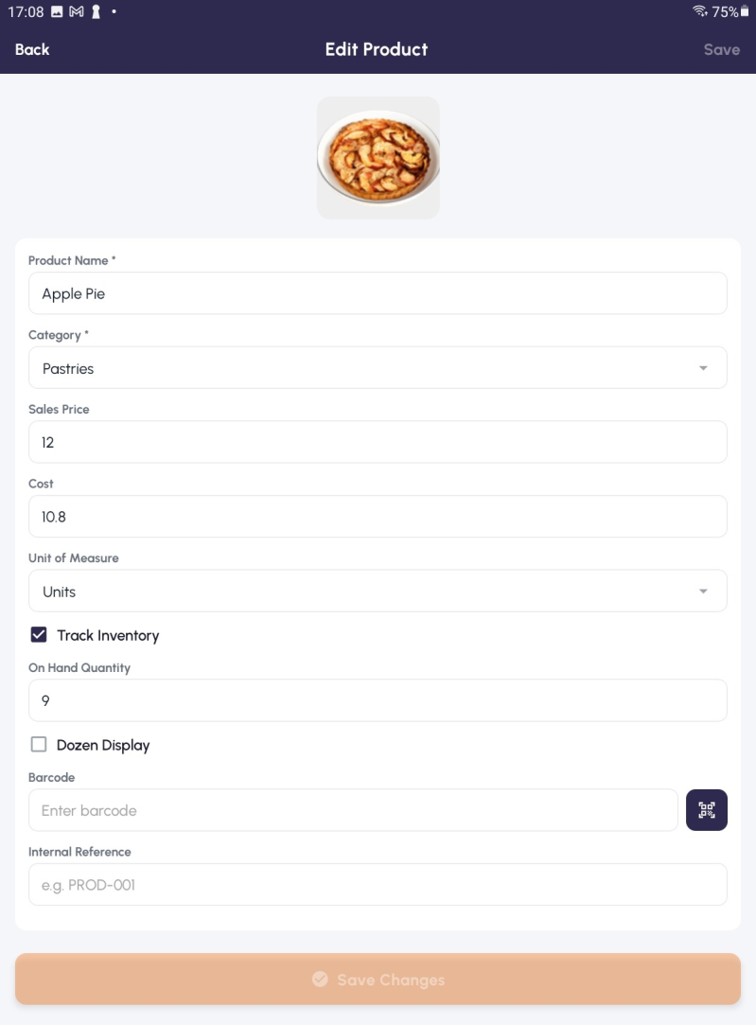
Edit Product — the form, with Track Inventory ticked and Save Changes greyed out until something actually changes.

The form, box by box
- Add Image — tap to pick a photo. It's cropped square for the product tiles.
- Product Name — the only box you absolutely have to fill in.
- Category — tap it to open the category picker (see below). A product can sit in more than one.
- Sales Price — what you sell it for.
- Cost — what it costs you.
- Unit of Measure — how it's counted: units, kilos, boxes, whatever you've set up.
- Track Inventory — tick it if you want the app keeping count of this one.
- On Hand Quantity — how many you've got. It only appears once Track Inventory is ticked.
- Dozen Display — tick it to enter and read the stock in dozens as well as pieces.
- Barcode — type it in, or tap the navy scanner icon and scan the product with the camera.
- Internal Reference — your own product code, e.g. PROD-001.
Sorting products into categories
Tap the Category box and the Select Category picker opens with a search box and one row per category, each with a tick box and its colour dot. Tick as many as apply — the picker
deliberately stays open so you can pick several — then close it with the ✕. The product's details
screen then lists them all, separated by commas.
You manage categories from right here rather than on a screen of their own. Tap Add Category at the bottom of the picker to create one, or the pencil on any row to rename it or change its colour. You get a name box and a grid of twelve colours; the colour you choose is what tints that category's chip on the Products list and on the POS product screen. A category you've just created is selected on the product straight away and shows up in the list without a refresh.
Units of measure
Tap Unit of Measure and you get a searchable list of every unit set up for your shop, with a pencil on each row to rename it and an Add Unit row at the bottom.
Adding a unit asks for three things: the Unit Name (say, "Pack of 20"), the Reference Unit it's built on (Units, unless you've set up something else), and Contains — how many of that reference unit make one of yours. As you type, a grey line underneath spells the answer back to you: 1 Pack of 20 = 20 Units. There's also a Group Products in POS tick box if you want products sharing this unit grouped together at the till. Save it and it's selected on the product immediately.
If the reference unit you need doesn't exist yet, tap the Reference Unit box and then Create Reference Unit — that makes a brand-new base unit other units can be built on. When you're editing an existing unit, that unit and anything built on it are hidden from the reference list, so you can't accidentally make a unit that refers to itself.
Track Inventory
Tick Track Inventory and the app keeps a running count of the product — that's what feeds the Stock screen and the little number on each product tile. The On Hand Quantity box appears underneath so you can set the starting figure.
Untick it on a product that still has stock and the app checks first: "This product still has 24 on hand. Disable Track Inventory?" Tap YES only if you really mean to stop counting it.
Counting in dozens
Some things are easier counted by the dozen than one at a time. Tick Dozen Display (it only appears once Track Inventory is on) and two more boxes open up:
- Pieces per Dozen — how many pieces make a dozen for this product. It starts at 12, but set it to whatever your supplier packs.
- On Hand (Dozens) — type the stock in dozens and the app works out the pieces for you.
As you type, a grey line underneath shows the answer the way you'd say it out loud — = 9 Dozen 7 Pcs. When you leave the box the app checks before changing anything: "Change On Hand from 24 to 36 pieces?" Tap YES and the On Hand Quantity is updated to match; tap NO and the dozens box goes back to what it was.
Afterwards, a product with Dozen Display switched on carries an extra On Hand (Dozen + Pcs) row on its details screen, reading something like 9 Dozen 7 Pcs.
Saving
There's a Save at the top-right and a Save Changes at the bottom — they do the same thing. On a product you're editing they both start greyed out and only wake up once you've actually changed something, so you can't save by accident. On a brand-new product they're active from the start.
You'll get a short "Product created" or "Product updated" message and be dropped back at the list. If part of it wouldn't save, the app says which fields didn't take and leaves the form open so you can try again.
Good to know
- Prices are always per single unit. Dozen Display changes how the stock is counted, not how it's priced.
- Dozens show on the product form and the product's details screen. Everywhere else — the product tiles, Stock, the till and the receipt — counts in plain pieces.
- Picking any category also makes the product available at the till, so a new product is sellable as soon as you've saved it.
- A product you can't find in the Unit of Measure list probably needs one creating — use Add Unit rather than forcing it into a unit that doesn't fit.
Deleting, archiving and restoring a product
What it's for
Products you've stopped selling clutter up the till. You can delete one outright, but only if it's never been used — the moment a product has been sold, the app won't let it go, because deleting it would tear a hole in your past orders. Archiving is the answer: it takes the product out of every list without touching a single thing it's been part of.
How to get there
From the Home screen: Home → Products, then tap the product you want to get rid of.
Step by step
- Open the product and tap the red Delete Product button.
- A box asks "Delete this product?" Tap OK to go ahead, or CANCEL to back out.
- If it goes through you'll see "Product deleted" and you're back at the list.
- If the product has been used, a Can't Delete Product box appears instead, with the reason underneath.
- Tap ARCHIVE INSTEAD. The product is filed away rather than deleted, everything it's been part of stays intact, and it disappears from the normal lists.
- Tap CLOSE if you'd rather leave it alone for now.
Getting an archived product back
Open Products and tap Show Archived on the grey strip above the tiles. The list swaps to the archived ones; tap Show Active to swap back. Open an archived product and instead of Edit and Delete you get a yellow "This product is archived" banner and a green Restore Product button. Tap it and the product is back in the normal list, exactly as it was.
Good to know
- Archiving is nearly always the right call. It keeps every order the product ever appeared on readable, and you can undo it in two taps.
- You only see Edit, Delete and Restore if your admin has given you permission to change products. Without it the buttons simply aren't there.
- An archived product can't be sold and won't come up in a search at the till.
Stock
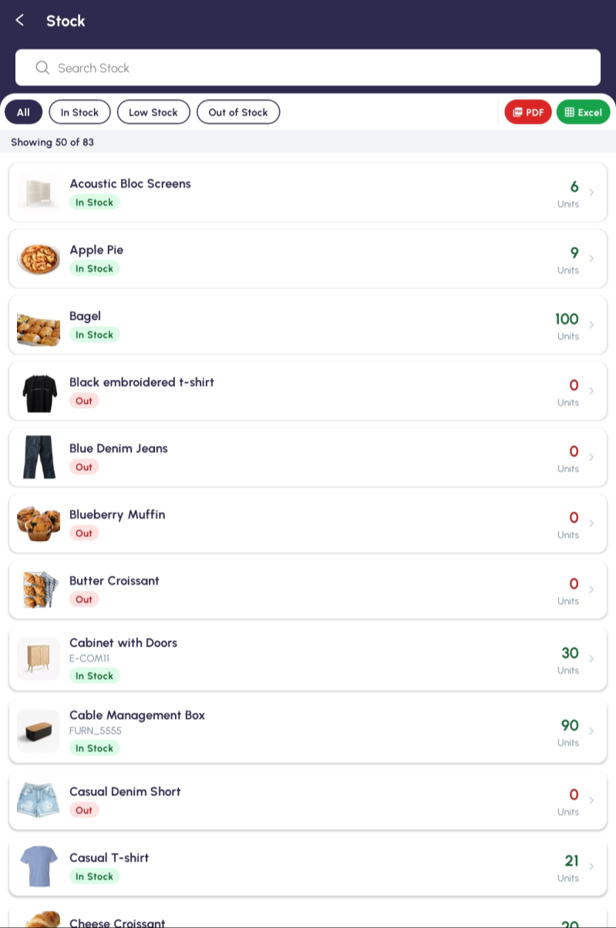
Stock — colour-coded counts so low and out-of-stock items jump out.

What it's for
Stock tells you how many of each item you've got right now. It's colour-coded — green for in stock, amber for low, red for out — so problems stand out. Filter to just the items that need reordering and export the whole thing to PDF or Excel.
How to get there
From the Home screen: Home → Stock.
Step by step
- Tap Stock on the Home screen.
- Every product shows with its count and a coloured label.
- Tap a chip — All, In Stock, Low Stock or Out of Stock — to filter.
- Search for one item in the box.
- Tap a product to see the breakdown by location.
- Tap PDF or Excel to export the list.
Good to know
- Run the Out of Stock filter first thing each morning so you know what to reorder before the day gets going.
- Stock looks after itself: it goes up when you mark a purchase done, and down with every sale.
PART 4 · BUYING (PURCHASES)
Easy Purchase
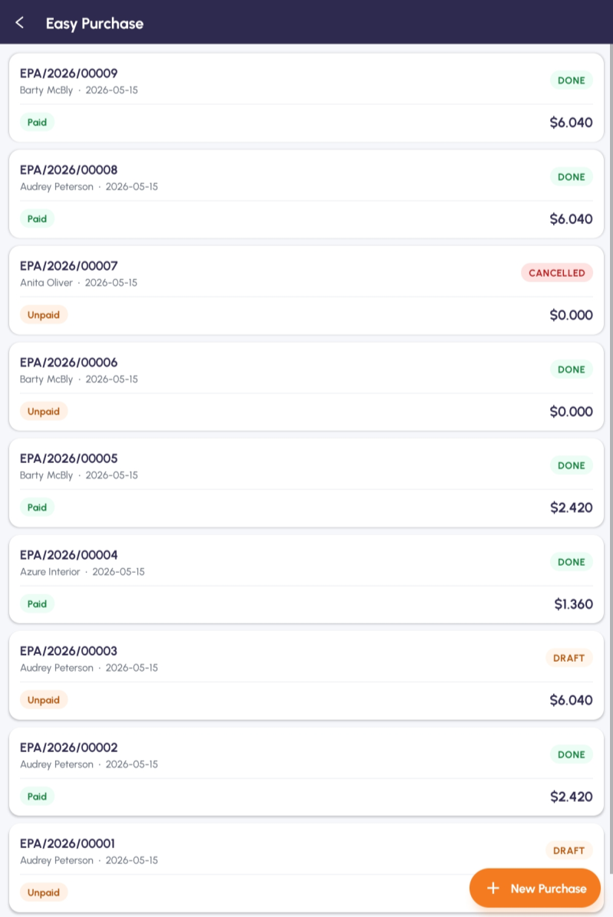
Easy Purchase — supplier orders with their status and payment state at a glance.

What it's for
Easy Purchase is the quick way to record what you've bought from a supplier. Each purchase has a vendor, a date, the items with quantities and costs, and a payment state. Mark one Done and your stock goes up automatically — and you can print barcodes for the new items if you need them.
How to get there
From the Home screen: Home → Easy Purchase.
Step by step
- Tap Easy Purchase on the Home screen.
- The list shows your purchases with their reference (EPA/…), vendor, date, status and amount.
- Tap New Purchase to create one.
- Pick the vendor from the dropdown.
- Set the date.
- Tap Add Line, pick a product, and enter the quantity and unit cost. Repeat for each item.
- Choose how you paid.
- Tap Save to keep it as a draft, or Save & Mark as Done to finalise it — that's what bumps your stock up.
- From a saved purchase you can tap Print Barcode to print stickers for what you received.
Good to know
- Status colours: orange is a draft, green is done, red is cancelled.
- Payment state — Paid (green), On Credit (blue), Unpaid (orange) — helps you see who you still owe.
- Buy the same things every week? Open an old purchase, change the date and save. Much faster than retyping it.
Quick Return
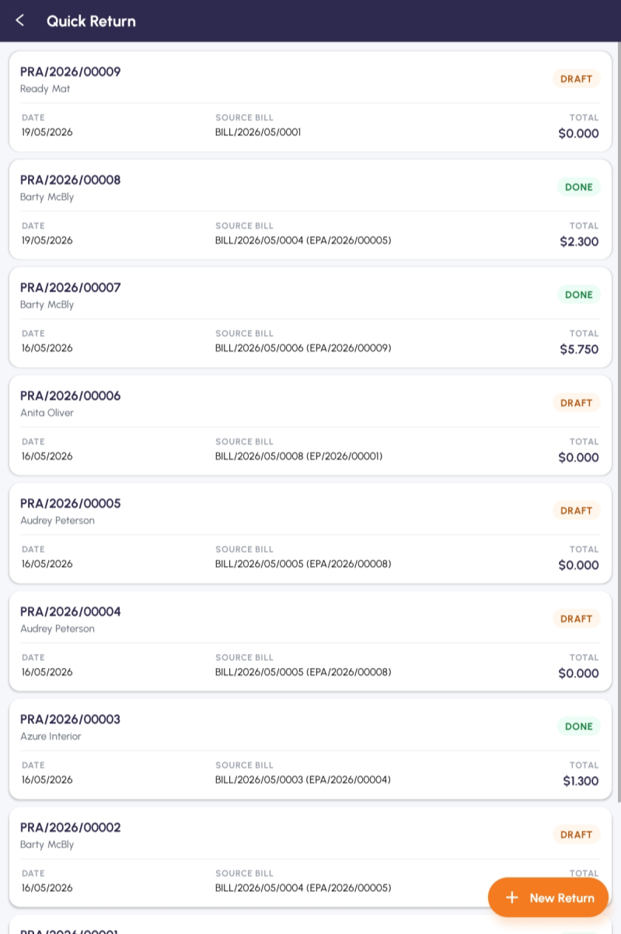
Quick Return — send goods back to a supplier against the original bill.

What it's for
Quick Return is the opposite of Easy Purchase: it's how you send goods back to a supplier. Each return (PRA/…) points at the original bill it came from, lists what's going back, and once confirmed it raises a supplier credit note and a return delivery — and takes those items back out of your stock.
How to get there
From the Home screen: Home → Quick Return.
Step by step
- Tap Quick Return on the Home screen.
- The list shows returns with their reference, vendor, date, the source bill and the total.
- Tap New Return to start one.
- Tap Vendor Bill and pick the posted bill you're returning against. Search by bill number if the list is long.
- The lines you're allowed to send back load on their own. If there aren't any, the app tells you so.
- Set the Return Qty on each line — see below for returning only part of a delivery.
- Check the Warehouse and the two switches underneath (see below).
- Tap Save to keep it as a draft, or Confirm Return to raise the supplier credit note and the return delivery.
- Open any return to see the linked credit note, the return delivery and the original bill, and to download a PDF.
Returning only part of a delivery
You rarely send a whole delivery back. Each product on the return is a card with six figures on it, so you can see exactly where you stand before you type anything:
- Purchased — how many were on the original bill.
- Already Returned — how many you've sent back on earlier returns.
- Max Returnable — what's left, which is the first two subtracted.
- Return Qty — the one box you can type in.
- Unit Price — what you paid for one.
- Line Refund — what this line comes back to, worked out as you type.
To return part of a line, just type a smaller number in Return Qty. Anything you leave at zero is left off the return altogether, and a product with nothing left to send back doesn't appear on the form at all. If you are sending everything back, tap Return all at the top of the Return Lines card and every line fills itself in to its maximum.
Type more than you're allowed and the box turns red straight away. Move off it and the app says "You can return at most 12 unit(s) of …" and puts the figure back to the maximum for you. Confirm Return stays greyed out until every line is within its limit, and if you've left them all at zero you'll get "Enter at least one return quantity".
Warehouse & Settings
Underneath the lines you pick the Warehouse the goods are leaving from, and there are two switches: Auto-Post Credit Note posts the supplier credit note the moment you confirm, and
Auto-Validate Return Picking marks the goods as gone at the same time. Leave them both on unless someone else in the shop checks this paperwork first. A navy card at the bottom keeps a running Total Lines and Total Refund.
Good to know
- Status colours match the rest of the app: orange draft, green done.
- Every figure on a return card is taken from the real bill, so you can't send back more than you bought — even across several returns.
- Once it's confirmed, the return's own screen links you straight to the credit note, the return delivery and the original bill under LINKED DOCUMENTS.
- Every return is tied to a real bill, so your supplier balances always add up.
The full Purchases workflow
The detailed procurement tools, reached from the Options → Purchases menu. Many shops only use Easy Purchase and never need these.
Beyond Easy Purchase, the app carries the full, formal buying process for shops that need approvals and paperwork. It lives under Options → Purchases and breaks into six steps:
Good to know
- Purchase Requisition — an internal "we need to buy this" request, before anything goes to a supplier.
- Price Enquiry — ask several suppliers for quotes, compare them, and turn the winner into an order.
- Purchase Order — the actual order you send to the supplier, with quantities, costs and tax.
- Delivery Note — record the goods arriving and move them into stock.
- Vendor Bill — the supplier's invoice, matched to the order and given payment terms.
- Supplier Payment — pay a vendor bill and tie the payment to it.
PART 5 · PEOPLE (CONTACTS)
Customers
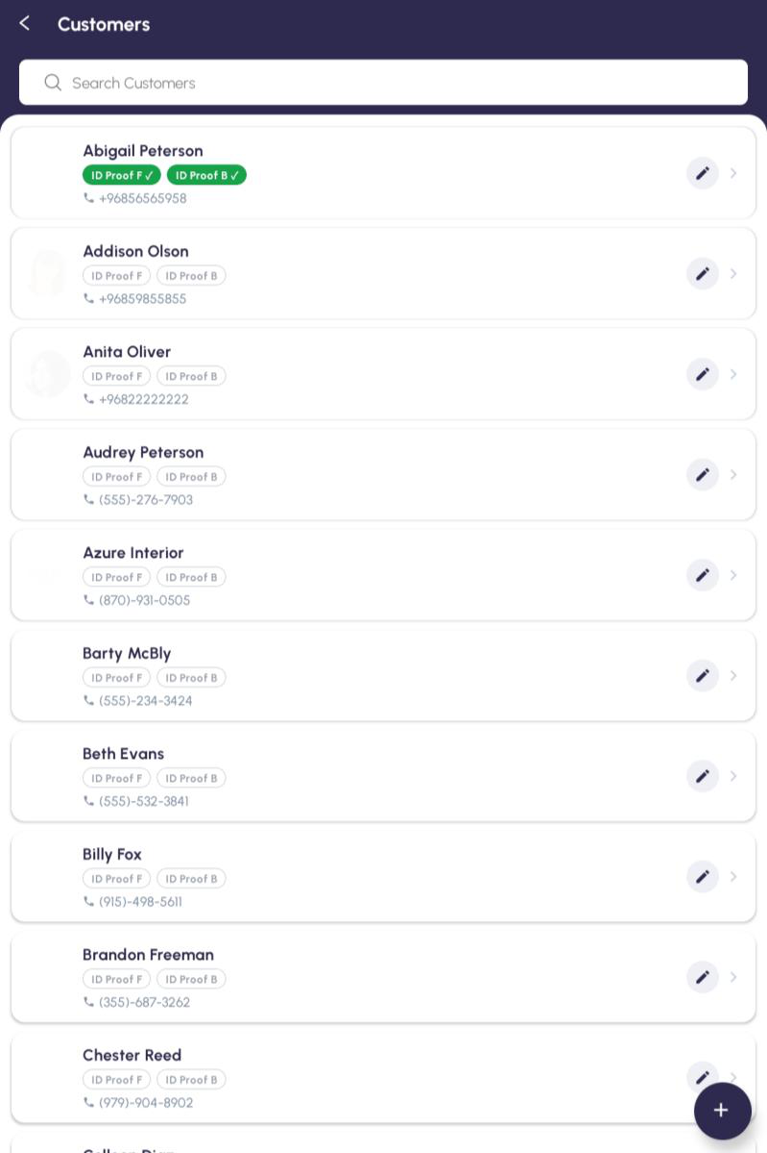
Customers — search by name or phone; the green ID Proof badges show who's verified.

What it's for
Customers is your address book of everyone who buys from the shop. Search by name, phone or email, add new people, and edit existing ones. Linking a customer to a sale means you can later see who bought what. The edit form is split into tabs so the details stay tidy.
How to get there
From the Home screen: Home → Customers.
Step by step
- Tap Customers on the Home screen.
- Scroll the list or search by name, phone or email.
- Tap a customer to see everything across the Details, Address, Contact Person and Other Details tabs.
- To edit, open them and tap the pencil / Edit.
- To add someone, tap the round + button at the bottom-right.
- On Details, enter name, phone, email and whether they're a business (B2B) or a walk- in (B2C).
- Fill in the Address tab — street, city, state, postcode, country.
- Use Contact Person for a separate contact at a business customer.
- Use Other Details for payment terms, credit limit and tax ID.
- Tap Save. They're now pickable during a sale.
Good to know
- At the till you can tap the customer field to open this same list and attach someone to the sale.
- Phone numbers match as you type, so adding the phone makes lookup quick at a busy counter.
- The green "ID Proof F / B" badges mean that customer already has their ID front and back on file.
Customer ID Proofs
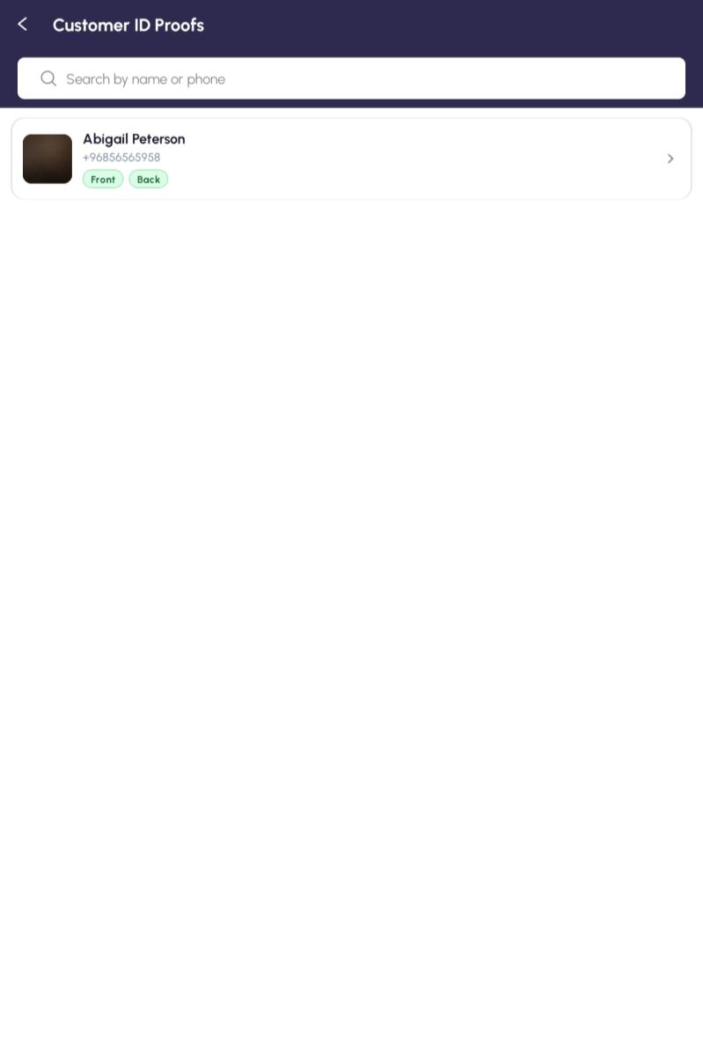
Customer ID Proofs — only customers with a photo on file show up here.

What it's for
Customer ID Proofs is the shortlist of customers who've had their ID photographed — handy for credit accounts, age-checked sales, or any time you need to confirm who someone is. You can view the front and back full-screen and add new ones with the camera or from the gallery.
How to get there
From the Home screen: Home → Customer ID Proofs.
Step by step
- Tap Customer ID Proofs on the Home screen.
- Only customers with at least one photo appear, each with a Front / Back badge showing what's on file.
- Search by name to narrow it down.
- Tap a customer to see the front and back full-size.
- To add an ID, open that customer from the Customers list, find the ID Proofs part and tap Upload Front or Upload Back.
- Choose Camera for a fresh photo or Gallery for an existing one.
- Check the preview — it's saved against the customer.
Good to know
- Good light and all four corners in the frame make the photo actually useful later.
- At payment time the till shows a small ID preview for the chosen customer so you can confirm identity at a glance.
PART 6 · MONEY (FINANCE)
Expenses
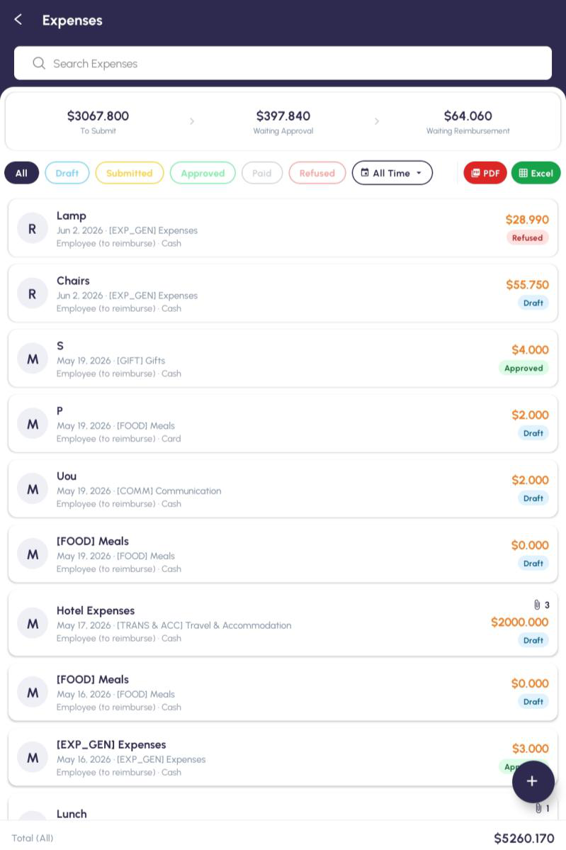
Expenses — the strip at the top shows what's waiting to be submitted, approved and reimbursed.

What it's for
Expenses is where staff log money they've spent for the shop — meals, transport, supplies and so on. Each expense moves through stages: Draft, then Submitted, then Approved, then Paid (or Refused). The summary across the top shows how many are sitting at each stage so nothing slips through.
How to get there
From the Home screen: Home → Expenses.
Step by step
- Tap Expenses on the Home screen.
- The strip at the top totals what's still To Submit, Waiting Approval and Waiting Reimbursement.
- Use the chips (All, Draft, Submitted, Approved, Paid, Refused) to filter.
- Tap the round + to add one.
- Type a short description (e.g. "Lunch with supplier").
- Set the date it happened — today by default.
- Pick a category.
- Enter the amount.
- Choose the payment mode — your own money or the company card.
- Attach the receipt photo if you have one, add any notes, and tap Save (it's now a Draft).
- Open it and tap Submit to send it to your manager for approval.
Good to know
- Status colours: blue draft, orange submitted, green approved, grey paid, red refused.
- If something's Refused, open it to read why, fix it, and submit again.
- You can attach more than one receipt — the paperclip number on a row shows how many are stuck to it.
PART 7 · ACCOUNTING
Invoices
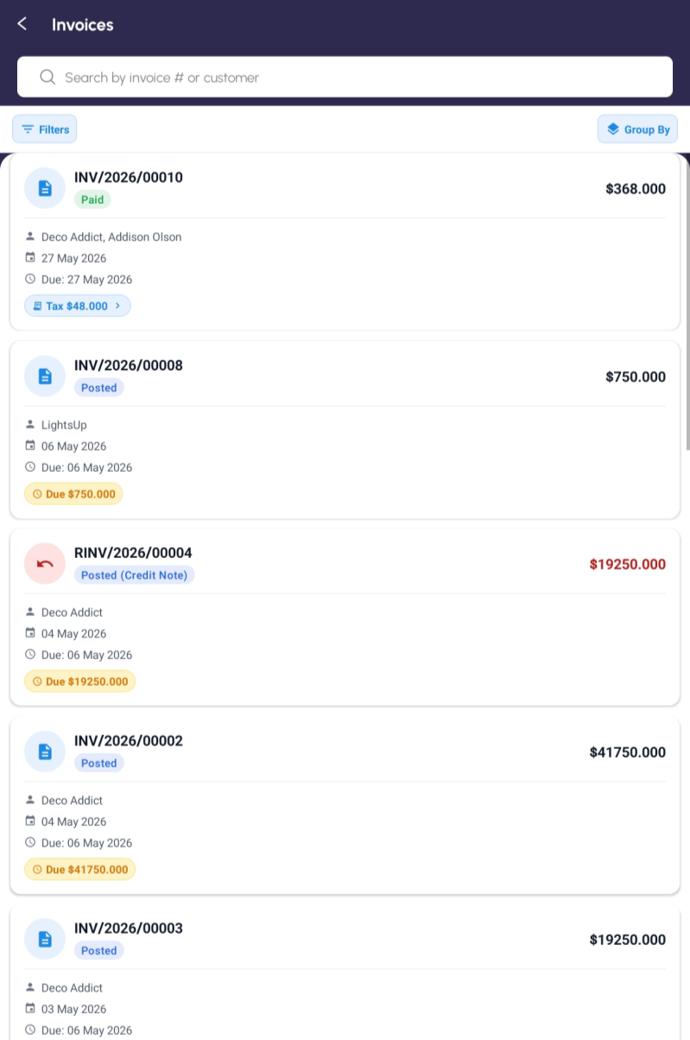
Invoices — Filters and Group By up top; tap a Tax chip to see the breakdown.

What it's for
Invoices is your customer billing. It lists customer invoices and credit notes, each showing its number, who it's for, the dates, the amount and whether it's paid. A coloured badge tells you the state — Paid, Posted, Draft or a red Credit Note — and a "Due" pill flags anything still owed.
Tap Filters to narrow by type (invoice or credit note), payment state (paid, partial, unpaid, in payment) or just the overdue ones. Tap Group By to bunch them by salesperson, customer, status, payment method or journal. Tap a blue Tax chip to see the tax line by line.
How to get there
From the Home screen: Home → Accounting → Invoices.
Finding and reading an invoice
- Tap Invoices in the Accounting section.
- Search by invoice number or customer in the box.
- Tap Filters to set type, payment state or overdue-only — you can tick more than one.
- Tap Group By to organise the list however suits you.
- Tap any invoice to open it in full.
What you can do on an open invoice
Opening an invoice shows its header (number, customer, dates, badges), the amounts (untaxed, tax, total, and what's still due), and the line items. Which buttons appear depends on the invoice's state:
- Post — turns a draft into a real, posted invoice.
- Reset to Draft — unposts a posted invoice so you can edit it (it asks you to confirm first).
- Credit Note — raises a reversal when something needs refunding.
- Cancel — marks the invoice cancelled.
- Pay — opens the payment box to record money received (only shows while something's still owed).
- Download PDF — saves or shares the invoice as a PDF.
- Print PDF — prints the invoice using your own shop's receipt design and paper size, rather than the standard A4 report.
Recording a payment (the Pay box)
Tap Pay and a box opens, laid out like the desktop accounts screen. On the left you pick the journal (the bank or cash account the money lands in) and, if you need it, the recipient bank account. On the right you set the amount — it defaults to the full amount due — the payment date, and an optional memo.
There's a reminder in the box to check you're not paying twice. When it's right, tap Create Payment. The invoice updates to Paid (or partly paid) and the new payment shows up in the accounts.
Saving a PDF
Download PDF fetches the printable invoice. On your mobile phone choose a folder to save it to Files, email it, and so on. The app checks the file actually came through properly before handing it over.
Print PDF — printing on your own layout
Next to Download PDF there's a Print PDF button, and the two do different things. Download PDF gives you the plain A4 invoice the back office produces, unchanged. Print PDF renders the same invoice through whatever receipt design your shop has set up under Invoice Settings — your logo, your header, your paper size — and hands it to the phone's print dialog.
It behaves the same way as a till receipt: if your admin has set a default paper size the printing starts immediately, otherwise you get the Choose receipt size box first. The button reads Preparing… while it works, and it doesn't appear on a draft invoice. Signatures are left off — accounting invoices aren't signed at the counter.
Good to know
- The list refreshes itself when you come back to it, so an invoice you just paid shows its new status without a manual refresh.
- A red amount with "Credit Note" is money going back to the customer, not money owed to you.
Journal Entries
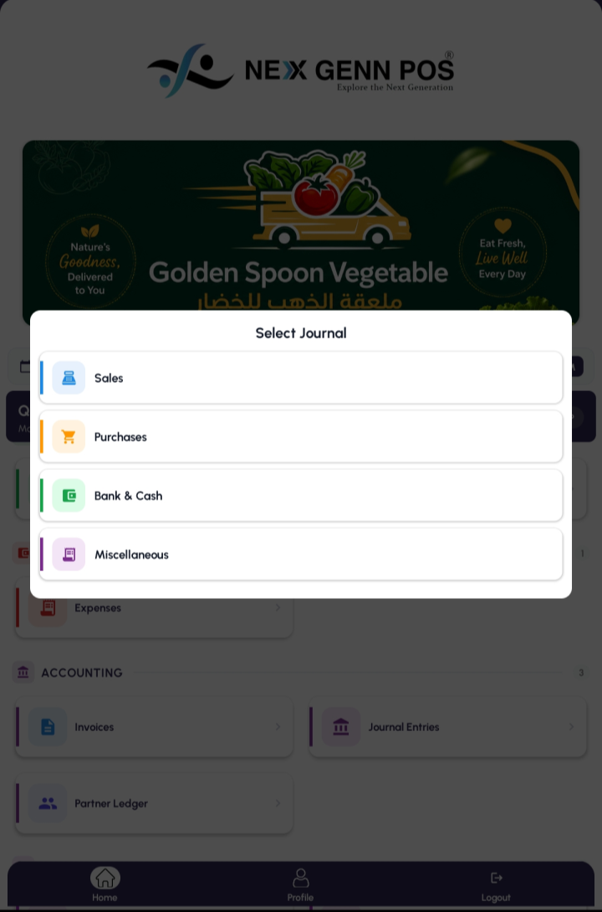
Tapping Journal Entries asks which set of books you want to look at.

What it's for
Journal Entries is the accountant's view of every transaction — the underlying bookkeeping behind your sales, purchases and payments. It's a read-only record: you look, you don't edit. Because there can be a lot of it, the app first asks which journal you want.
How to get there
From the Home screen: Home → Accounting → Journal Entries, then pick a journal.
Choosing a journal
Tapping Journal Entries opens a Select Journal popup with four choices:
- Sales — entries behind your customer invoices.
- Purchases — entries behind your supplier bills.
- Bank & Cash — money in and out of your bank and cash accounts.
- Miscellaneous — everything else, including the entries POS creates for each session.
Reading the list (Journal Entries - Sales)
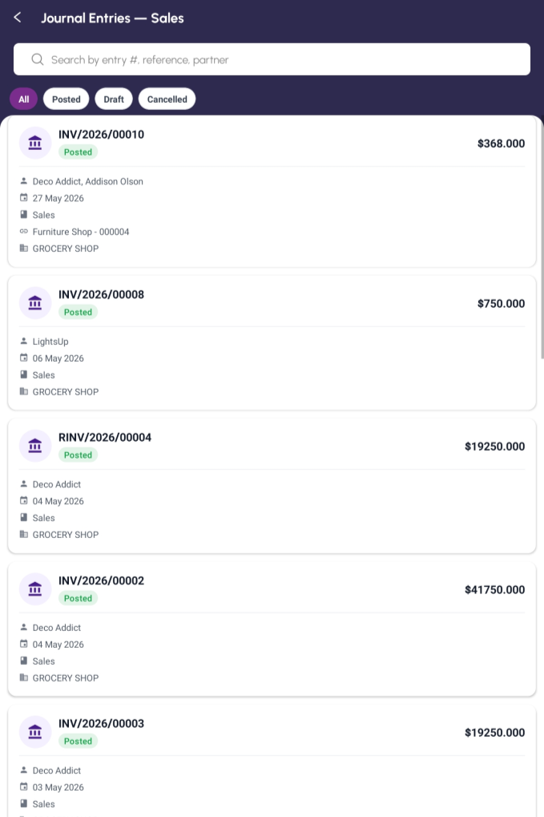
Journal Entries — Sales. Each row shows the entry number, status, partner, date, journal and shop.

Whichever journal you pick, the list works the same way. Each row shows the entry number, a Posted / Draft / Cancelled badge, the partner, the date, the journal name and the shop. Filter with the All / Posted / Draft / Cancelled chips, or search by entry number, reference or partner.
The other journals look the same (Journal Entries – Bank & Cash)
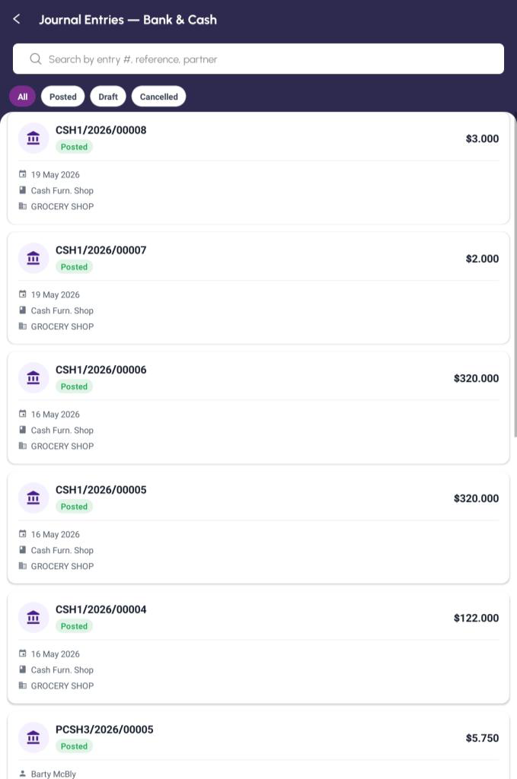
Bank & Cash entries (CSH…) — cash movements per shop.

Journal Entries – Miscellaneous
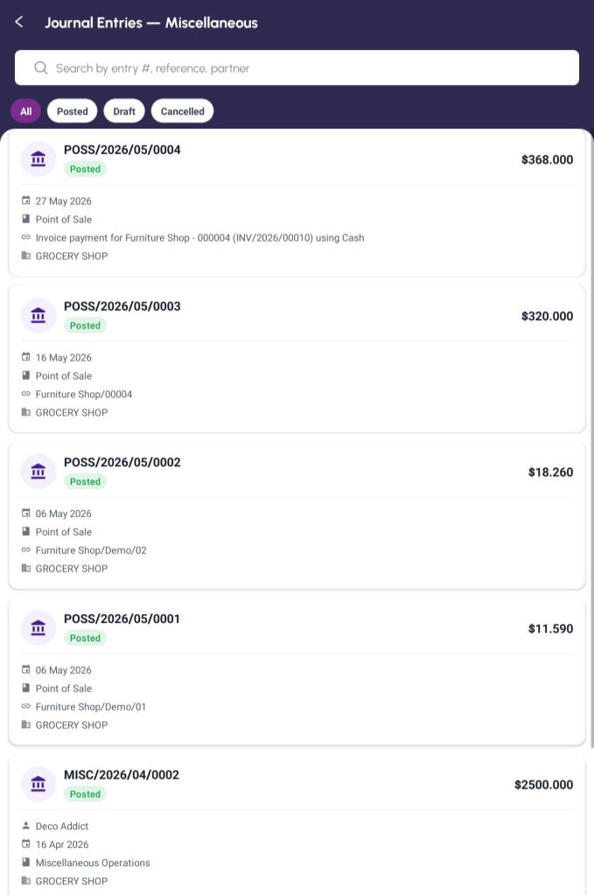
Miscellaneous entries (POSS…) — including the lines POS posts for each payment.

Good to know
- This screen is for checking the books, not changing them — there's nothing to edit here.
- The list refreshes when you return to it, so freshly posted entries appear on their own.
Partner Ledger
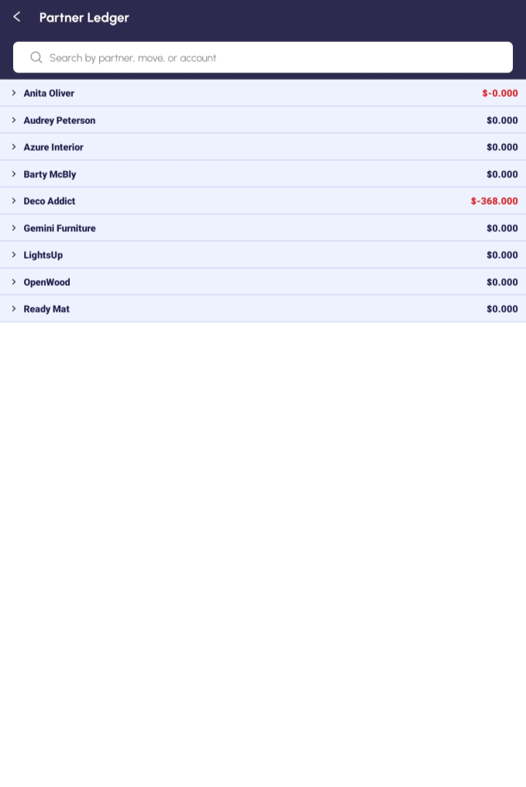
Partner Ledger — every customer and supplier, with what they owe and what you owe them.

What it's for
Partner Ledger answers "who owes what?" in one screen. Every customer and supplier gets a row with their balance, and you can open any of them to see the transactions behind it. It's the fastest way to spot a debt that needs chasing or a supplier you still have to pay.
How to get there
From the Home screen: Home → Accounting → Partner Ledger.
Step by step
- Tap Partner Ledger in the Accounting section.
- It opens already filtered to Posted and With residual — in other words, real entries with money still outstanding. You'll see those two as blue chips under the search box.
- Each partner is a single row showing their name, how many lines sit behind it, and their Debit, Credit and Balance.
- Tap a partner row (or its chevron) to open it up. Rows start closed so the screen stays readable.
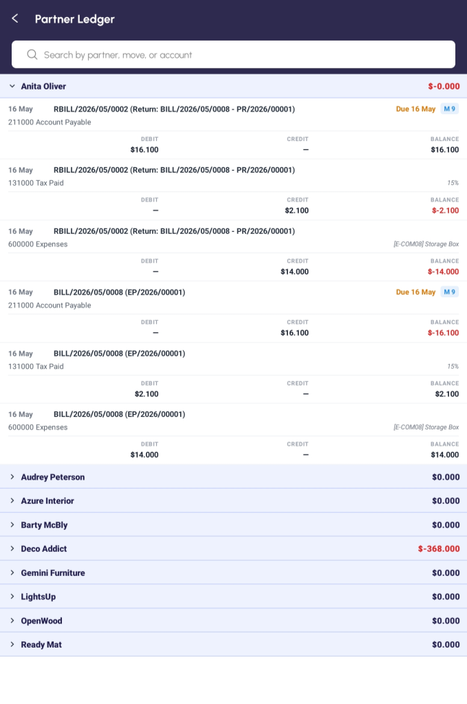
Expanded — every line for that partner, with its debit, credit, balance and due date.

- Underneath you get every transaction for that partner, in a table you can scroll sideways: Date, Journal Entry, Account, Label, Debit, Credit, Due Date, Balance and Matching.
- Tap any single line to jump straight to the invoice or journal entry behind it.
- Search by partner, journal entry or account name to go straight to one.
- A Total row is pinned along the bottom with the Debit, Credit and Balance for everything your filters have let through — not just what's on screen.
Narrowing the list down
The filter icon at the top-right opens a Filters box. Everything you switch on there appears as a blue chip under the search box, and the screen title counts them for you — Partner Ledger
(3). Tap the ✕ on a chip to drop just that one; tap Clear in the box to start again, or Apply to
set them.
- Posting Status — Unposted, Posted.
- To Review — entries someone has flagged as needing a look.
- Reconciliation — Unreconciled, With residual.
- Journal — Sales, Purchases, Bank, Cash, Credit, Miscellaneous.
- Accounts — Payable, Receivable, P&L Accounts.
- Date and Invoice Date — open either one and pick a period. You're offered only the months, quarters and years that actually have something in them, so there are no empty results to wade through.
Good to know
- Red is money outstanding; black zeros are settled accounts.
- It's a read-only report — to actually take a payment, open the invoice or bill and use Pay there.
- The Balance column is the balance of that one line, not a running total down the page. The running position is the partner's own row and the Total row at the foot.
- The list loads a hundred lines at a time as you scroll, but the Total row is worked out across everything, so it's right even before you've scrolled to the bottom.
- Because it opens on Posted and With residual, a partner who has paid you in full won't be there at all. Clear those chips if you want to see everybody.
PART 8 · ADMIN (ADMINISTRATORS ONLY)
Users
ADMINS ONLY For administrators only. If you don't see this on your Home screen, your admin has hidden it for your account — that's normal.
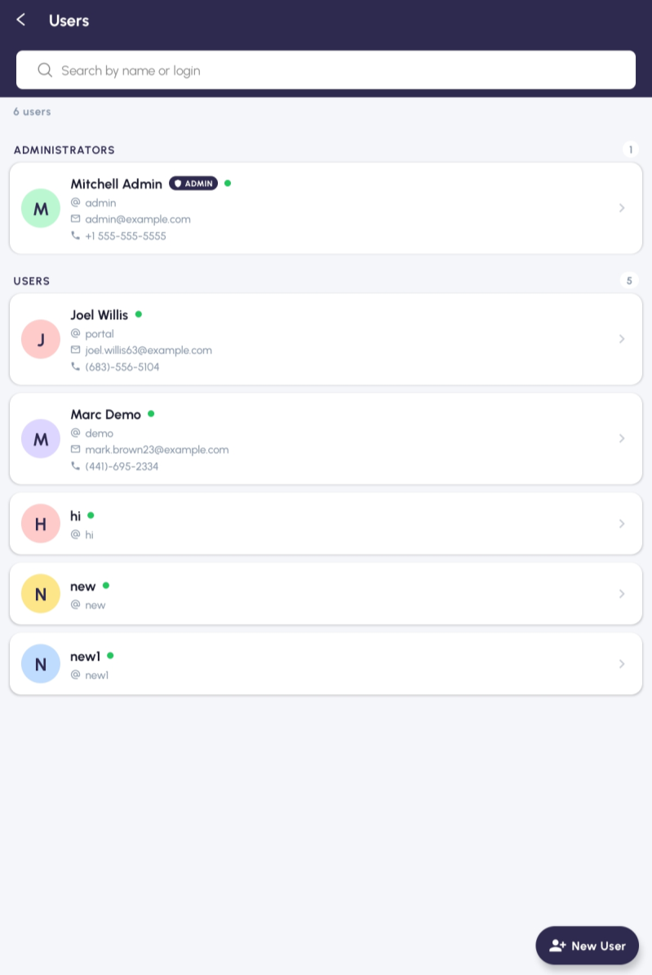
Users — split into Administrators and everyone else; the green dot means active.

What it's for
Users lists everyone who can sign in. It's split into two groups — Administrators and Users — so you can see at a glance who has the keys to everything. From here you add new people, edit existing ones, and switch accounts on or off.
How to get there
From the Home screen: Home → Users (admins only).
Step by step
- Tap Users on the Home screen.
- If you're not an admin you'll get an "access denied" message and be sent back — that's expected.
- Browse the Administrators and Users groups. Each card shows the initial, name, login, email and a green dot if they're active.
- Search by name, login or email.
- Tap New User to add someone — name, email, login, password, and whether they're an administrator.
- Tap a card then Edit to change someone.
- To stop someone signing in, open them and switch Active off — they keep their history but can't log in.
- Save.
Good to know
- Give every member of staff their own login — never a shared one. The reports rely on knowing who did what.
- Switching someone off is safer than deleting them: it keeps the record of which orders they created.
App Banners
ADMINS ONLY For administrators only. If you don't see this on your Home screen, your admin has hidden it for your account — that's normal.
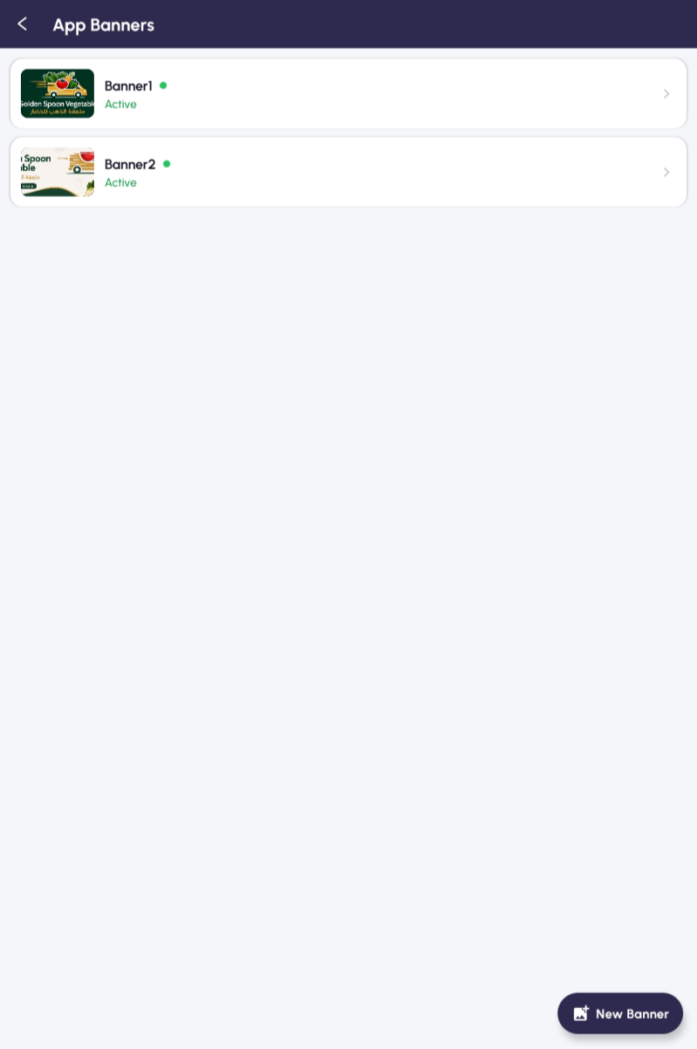
App Banners — the slideshow that runs across the top of everyone's Home screen.

What it's for
App Banners controls the pictures that slide across the top of the Home screen for everyone. Use them for offers, festival greetings or a notice to staff. Each one can be switched on or off without deleting it.
How to get there
From the Home screen: Home → App Banners (admins only).
Step by step
- Tap App Banners on the Home screen.
- You'll see the banners you've already got, each with its image and an Active / Inactive marker.
- Tap New Banner to add one.
- Give it a title (for your own reference).
- Upload the image — Camera, Gallery, or paste a web link.
- When the preview looks right, switch Active on.
- Tap Save. It now appears on every user's Home screen.
- To change or remove one later, tap it, edit, and save — or delete it.
Good to know
- Wide, landscape images look best — roughly three times as wide as they are tall.
- Switch a banner Inactive rather than deleting it if you might want it again (next year's festival, say).
Apps Privileges
ADMINS ONLY For administrators only. If you don't see this on your Home screen, your admin has hidden it for your account — that's normal.
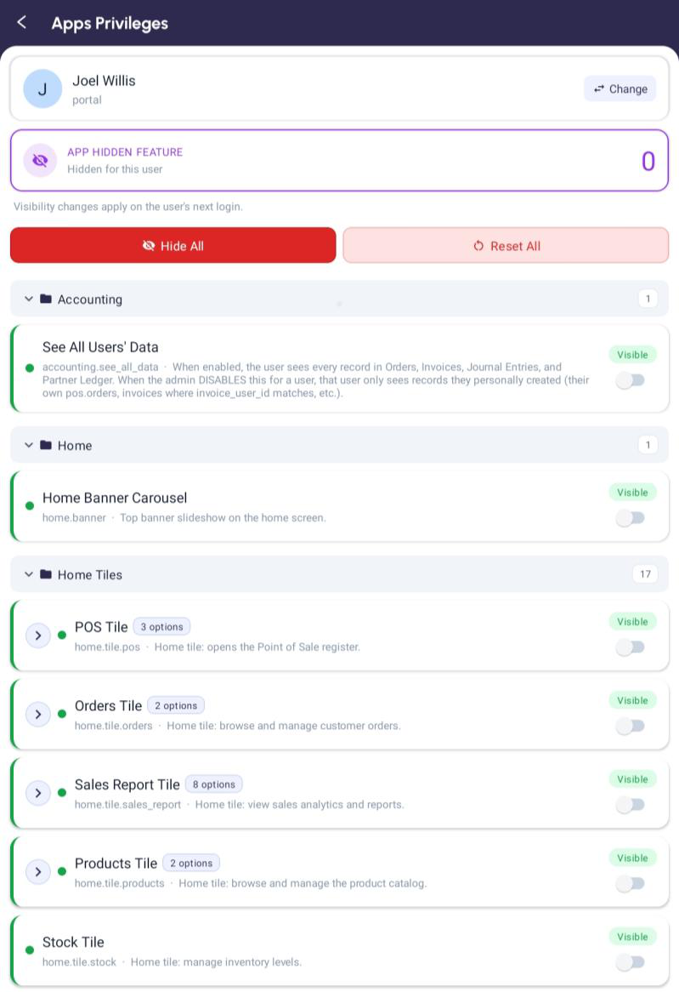
Apps Privileges — pick a person, then switch features on or off for them.

What it's for
Apps Privileges is how you decide what each person can see and do. New users start with everything visible; here you hide the bits a particular person doesn't need. Hide Sales Report from cashiers, hide Easy Purchase from staff who don't deal with suppliers — that kind of thing.
It goes deeper than whole screens, too. Many tiles have sub-options inside them (the screenshot shows POS with 3 options, Sales Report with 8, and so on), so you can allow someone the POS tile but still lock just the price-editing inside it.
How to get there
From the Home screen: Home → Apps Privileges (admins only).
Step by step
- Tap Apps Privileges on the Home screen.
- Tap the user card at the top (Change) and pick the person you're setting up.
- The "App Hidden Feature" box shows how many things are currently hidden for them.
- Scroll the features — they're grouped (Accounting, Home, Home Tiles, and so on). Tap a group to open it; tap a tile with "options" to see its sub-switches.
- Each switch is On for visible, Off for hidden. Flip off whatever they shouldn't see.
- Tap Save when you're done. A note reminds you the change takes effect at the user's next login.
Two shortcuts: Hide All and Reset All
- Hide All switches off everything for that person — handy when you want to start from nothing and only turn back on the few things they need.
- Reset All puts everything back to visible.
The line-price lock
Inside the POS tile's options is the control for editing prices on an order. Leave it on and the person can tap a line and change its price; switch it off and prices are fixed for them. Use this for junior cashiers who should sell at the set price, while supervisors keep the freedom to adjust.
"See All Users' Data"
Near the top sits a special one — See All Users' Data. With it on, the person sees every order, invoice, journal entry and ledger line in the shop. Switch it off and they only see the records they created themselves. It's the difference between a manager who sees the whole shop and a cashier who only sees their own sales.
Good to know
- Changes apply the next time the person logs in — they won't see them mid-session.
- Hiding a screen isn't the same as deleting data. Hide POS from someone and they can't sell, but their past sales are untouched.
- The Apps Privileges tile itself can't be hidden, so you can't accidentally lock yourself out of it.
Invoice Settings
ADMINS ONLY For administrators only. If you don't see this on your Home screen, your admin has hidden it for your account — that's normal.
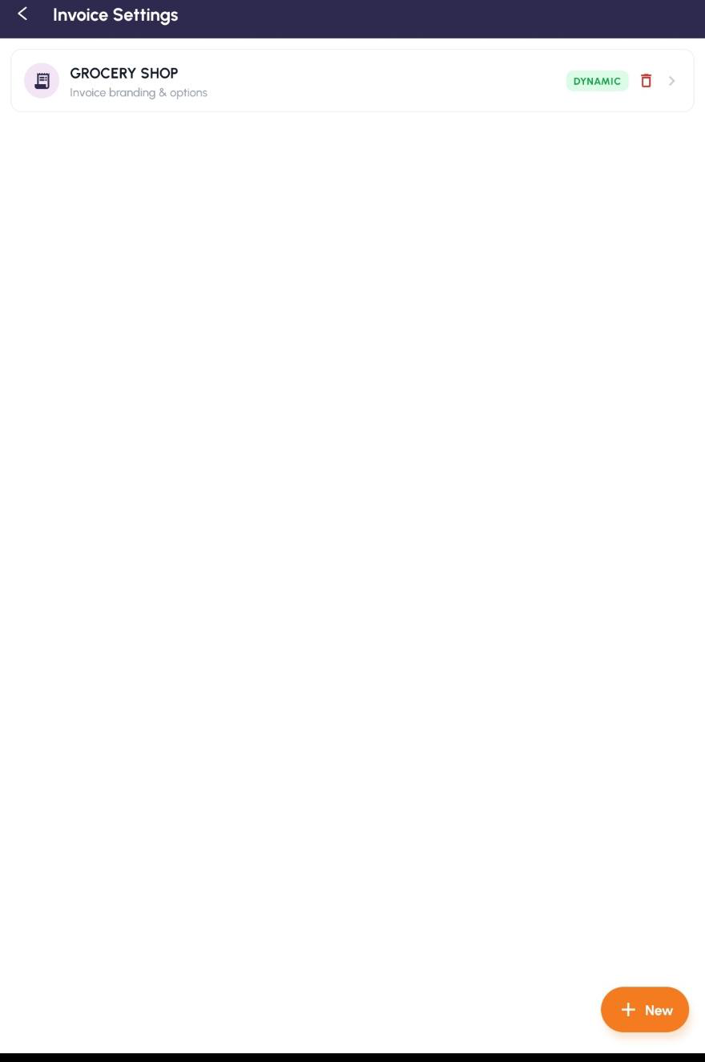
Invoice Settings — one row per company; the tag shows which receipt that shop is using.

What it's for
Invoice Settings lets you design the receipt the app prints and shares, without waiting for an app update. You choose which of four receipt designs the shop uses, put your own logo and details on it, and decide what shows and what stays hidden. Each company in your business keeps its own settings, so a group with more than one shop can brand each one differently.
The screen opens on a list with one row per company, tagged with the design that company is on. Tap a company and you get three cards: General Settings for the design and the branding,
Receipt Paper Sizes for the papers you print on, and Invoice Layouts for the drag-and-drop designer. The last two have chapters of their own after this one.
How to get there
From the Home screen: Home → Administration → Invoice Settings (admins only).
Step by step
- Tap Invoice Settings on the Home screen. You land on a list with one row per company and a coloured tag showing which design it's on.
- Tap a company's row to open it, or tap New at the bottom-right to set one up for a company that hasn't got any settings yet.
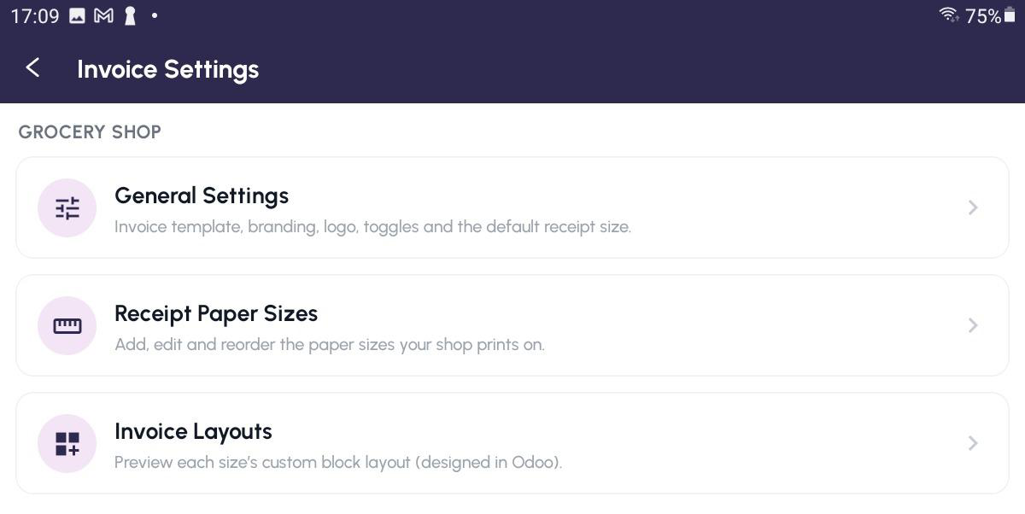
Invoice Settings — the three cards: General Settings, Receipt Paper Sizes, Invoice Layouts.

- Tap General Settings.
- At the top, pick the Invoice Template — Standard, Dynamic, Cash Memo or Custom Layout. This is the setting that decides everything else (see below).
- Tap Preview to see the receipt rendered against your most recent real sale, so you can check it before anyone else sees it. It appears for every design except Standard, which has nothing to configure.
- Pick the Company the settings belong to.
- Set Use Default Receipt Size if you want the app to stop asking what paper you're printing on, then choose the Default Size underneath.
- Fill in the branding for whichever design you picked, add your Logo, and set the Header Title and Footer Text.
- Under Show / Hide on Receipt, switch the Tax row, Customer signature, Cashier signature and Footer on or off.
- Tap Save Settings. The next receipt the app prints or shares uses your changes straight away.
The four receipt designs
The Invoice Template setting at the top replaces what used to be a single on/off switch. Everything below it changes to suit whichever one you pick.
- Standard — the app's plain built-in receipt. Nothing to set up; it just works.
- Dynamic — the branded receipt: your logo, your address, your VAT number, your own header and footer.
- Cash Memo — a bilingual English/Arabic invoice in the Oman style, meant for A4 and A5. It has a chapter of its own further on.
- Custom Layout — the receipt is built from blocks you arrange yourself, one layout per paper size, in the visual editor. See "Invoice Layouts".
It's safe to set everything up first and switch the design over at the end — nothing you type is lost by leaving the shop on Standard while you work.
Not being asked for the paper size
Use Default Receipt Size is on this screen and applies to every design. Switch it on and pick a Default Size, and Preview, Download and Print all go straight through at that size. Switch it off and the app asks each time. The sizes on offer are the ones you've set up under Receipt Paper Sizes.
Branding
Anything you leave blank falls back to the company's own details, so you only need to fill in what's different. Besides the Address, Phone, Email and VAT / GST Number, there are four fields for shops in Oman: a Company Name (Arabic) that types right-to-left, a C.R. Number, a GSM / Mobile number, and a switch for the Sultanate of Oman line. Each one has its own Show switch, so you can keep a value on file and still keep it off the printed receipt.
Those four are shared with the Cash Memo design — type your C.R. number once and both use it — but each design keeps its own set of Show switches, so hiding something on one doesn't hide it on the other.
Cash Memo header
With Cash Memo picked, a Cash Memo Header card replaces the branding one. It holds the Company Name in English and in Arabic, the C.R. Number, the GSM / Mobile and the VAT Number, each with its own Show switch, plus Show Sultanate of Oman. Leave a box empty and that line simply doesn't print.
Logo, header and footer
Tap Change logo and pick any image — it's resized for the receipt for you — or Remove logo to take it off. The Show logo switch hides it from the print without deleting it. Header Title is the line across the top (INVOICE, say) and Footer Text is your thank-you line at the bottom; both take two languages on separate lines if you need English and Arabic.
Good to know
- Each company has one saved row. The list tags every company with the design it's on, so you can see at a glance which shops are branded.
- Switching a company back to Standard doesn't lose your branding — it just parks it. Switch back and everything you set is still there.
- Changes made here and changes made in the back office are the same settings. Edit wherever is handier; the next receipt reflects it.
- Back out with unsaved changes and the app asks first, offering Stay or Discard.
- Only administrators can open Invoice Settings, so cashiers can't change how the receipt looks.
Receipt Paper Sizes
ADMINS ONLY For administrators only. If you don't see this on your Home screen, your admin has hidden it for your account — that's normal.
What it's for
This is the list of papers your shop prints on. Whatever's here is what the till offers when it asks for a receipt size, and what you can pick as the shop's default. Most shops set this up once and never come back.
How to get there
From the Home screen: Home → Invoice Settings → tap your company → Receipt Paper Sizes (admins only).
Step by step
- Open Receipt Paper Sizes. Each row shows the size's name and its measurements underneath, e.g. 80 × 210 mm, or 76 mm (auto height).
- Tap New to add one.
- Type the Size in inches — say 3.5 — and the Width fills itself in (an inch is 25.4 mm). You can still adjust the width by hand afterwards.
- Set the Height in millimetres, or leave it at 0 for one long continuous page — which is what you want for a till roll.
- Tap Save. The size is now offered at the till.
- Use the up and down chevrons to put the sizes in the order you want them offered, the pencil to change one, and the bin to remove one.
Good to know
- Every size gets its own layout under Invoice Layouts, so a wide sheet and a narrow roll can be laid out differently.
- There's one Custom row per company that can't be edited or deleted — it's what backs the "Custom width" option at the till.
- A size that's in use as somebody's default won't delete until you point that setting somewhere else.
Invoice Layouts
ADMINS ONLY For administrators only. If you don't see this on your Home screen, your admin has hidden it for your account — that's normal.
What it's for
If the built-in designs don't give you what you want, you can build the receipt yourself out of blocks — the logo, the company header, the items table, the totals, the signatures and so on — and drag them into place. There's one layout per paper size, so an A4 invoice and a 3-inch till receipt can look completely different.
Layouts only take effect when the company's Invoice Template is set to Custom Layout. Until then you can design and preview them safely without changing what anyone prints.
How to get there
From the Home screen: Home → Invoice Settings → tap your company → Invoice Layouts (admins only).
Step by step
- Open Invoice Layouts. There's a row per paper size, showing the layout's name and whether it's a Grid or a Flow layout.
- Tap the orange eye icon on any row for a print-exact preview without opening anything.
- Tap the row itself to open the layout.
- The detail screen lists its Blocks. Each one has arrows to move it up or down and a switch to show or hide it.
- Add section puts a new block in; Reset puts the whole layout back to how it started, after asking first.
- Tap Open Visual Editor for the full designer.
The visual editor
The editor turns the phone to landscape and gives you three panels side by side, the same as the back office: DESIGN on the left with the blocks, OPTIONS in the middle for whichever block you've tapped, and LIVE PREVIEW on the right that redraws as you work. Everything saves itself as you go — the green "auto-saved" marker tells you so — and there's Undo and Redo along the top if you go wrong.
The Grid / List button flips how you place blocks. Grid lets you drag and resize them anywhere, which is handy for a full sheet; List stacks them in order, which is what you want for anything printing on a roll. There's a reminder on screen that List is the one that comes out print-exact.
The blocks you can use are: Logo, Company Name in English and in Arabic, Company Header, Title, Order Fields (number, date and customer), Items Table, Totals, Payments, Signatures, Footer, Barcode, QR Code and Custom Text.
Tap a block and the OPTIONS panel offers Visible, Align, Direction (for right-to-left text), Width, Font size, Bold and a Flip side button. Some blocks have their own extras — a Title or Totals block takes a label in English and in Arabic, a QR Code block takes the text or address it should encode, a Barcode block asks what it should carry, and the Company Header block holds a list of rows you can label, fill in, reorder and hide one by one.
Good to know
- The company name and the Company Header rows are shared by every layout — change them in one and they change everywhere. The editor warns you when you're touching one.
- Preview needs at least one real sale to draw against. On a brand-new shop, ring something up first.
- Add a paper size and it gets a layout automatically, so start with Receipt Paper Sizes and come here afterwards.
The Cash Memo invoice
What it's for
Cash Memo is a bilingual English and Arabic invoice laid out the way Oman expects, meant for A4 and A5 but able to squeeze onto a till roll. You turn it on by setting the company's Invoice Template to Cash Memo; after that it's what the app prints, previews and shares everywhere.
What's on it
- A boxed header. On A4 and A5 it's three columns — your details in English on the left, your logo with the company name in Arabic above the English underneath it in the middle, and the same details mirrored in Arabic on the right. On a narrow roll it stacks into one centred column instead.
- C.R. No, GSM, Sur-Sultanate of Oman and VAT No, each printed only if you've switched it on under Invoice Settings.
- The title INVOICE / فاتورة across the middle.
- Four dotted lines for the order details — No / الرقم, Date / التاريخ, Name / االسم and Address / العنوان.
- The items table, with each heading in English above its Arabic — Sl No, Description, Quantity and Amount.
- The amount spelled out in words in an In Words / المبلغ كتابة box on the left.
- The totals box on the right: Total, Advance and Due, plus Previous and Balance when the customer still owes you from before.
- A signature row along the bottom — Cashier / الكاشير on the left, Customer / العميل on the right. If signatures were captured at the till they print above the line; if not, the line is left blank to sign by hand.
Good to know
- Every line of the header can be switched off on its own, so you only print what you actually need.
- The logo is deliberately large on this design — it's sized against the width of the paper.
- Accounting invoices printed on this design leave the signature row off, since they're not signed at the counter.
User Manual
What it's for
This is where this guide lives inside the app, along with any other documents your admin has put there. Nobody has to hunt for a PDF in their email — it's on the phone, and it's always the current version, because the documents come from the back office rather than from the app itself.
How to get there
Two ways. Administrators get a User Manual tile in the Administration section of the Home screen. Everyone else opens it from the bottom bar: Profile → HELP → User Manual.
Step by step
- Open User Manual. Each document shows a red PDF icon, its title and the file name underneath.
- Tap the one you want.
- A box asks how you'd like to use it — View opens it in your phone's PDF app, Download saves a copy to the device.
- Drag the list down to check for new documents.
For administrators
Admins get an orange Add button, plus a pencil and a bin on every row. Adding or editing asks for a Title and a PDF — tap Choose PDF (or Replace PDF) and pick the file — then Save. Deleting asks you to confirm first.
Documents can also be uploaded in the back office under the User Manual menu. Either way they show up in the app straight away — nobody needs a new version of the app.
Hiding it from staff
On the Profile screen, admins get a Show to users switch under the User Manual row. Turn it off and staff on that device stop seeing the manual; administrators always see it either way. It's set per device, and it starts switched on.
Good to know
- If the list says the manual isn't set up on this server yet, the back-office side hasn't been installed. Your admin can sort that out.
- Downloaded copies are ordinary PDFs — they'll open, print and email like any other file.
PART 9 · WRAPPING UP
Your Profile
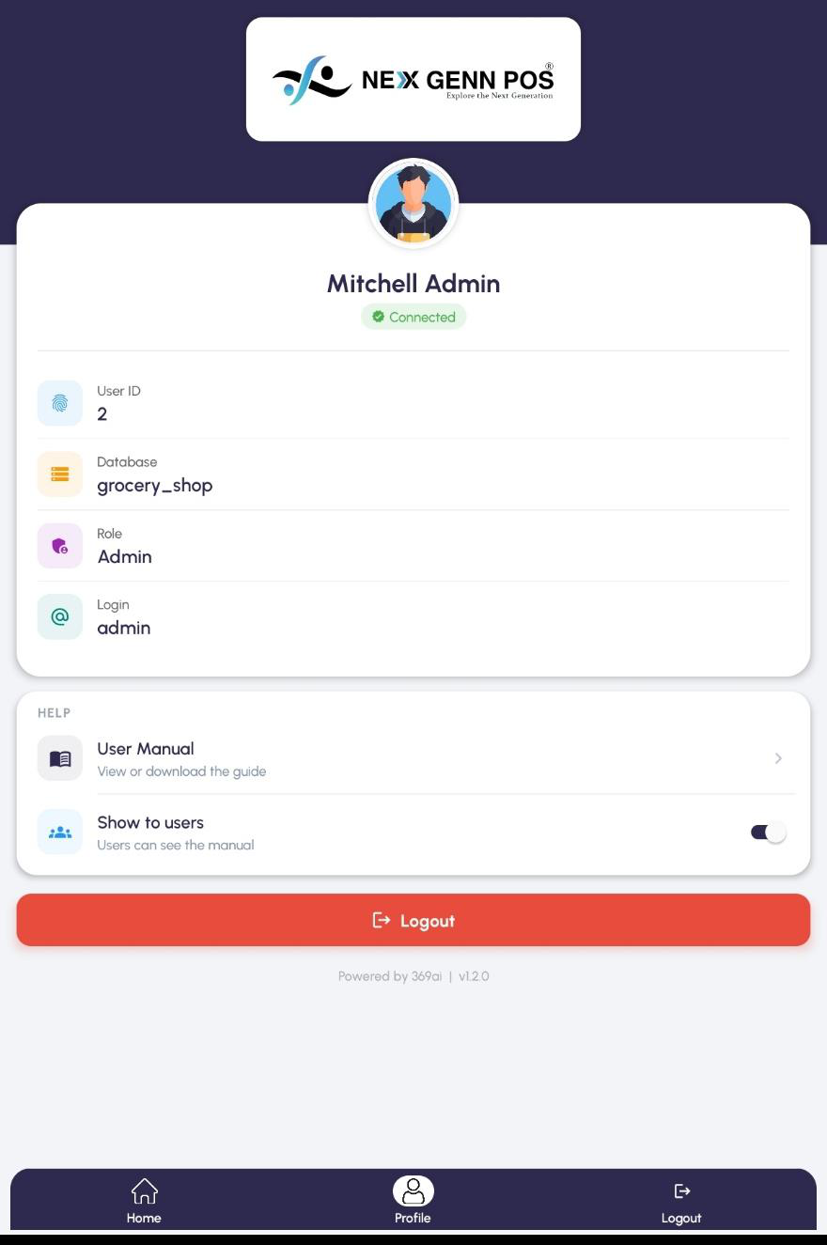
Profile — who you're signed in as, which shop, and the app version.

What it's for
Profile is your account at a glance — your name, your user ID, the shop database you're connected to, your role and your login. It's also where you open the user manual, and there's a big Logout button if you'd rather sign out from here than from the bottom bar.
How to get there
From the Home screen: Tap Profile in the bar at the bottom of the screen.
Step by step
- Tap Profile at the bottom.
- Check the green Connected badge — that means the app is talking to the shop's system fine.
- Your details are listed: User ID, Database, Role and Login.
- Tap Logout here if you want to sign out.
Help and the user manual
A HELP card sits below your details with a User Manual row on it — tap it to open the guides your admin has uploaded. Administrators get a second row, Show to users, with a switch that decides whether everyone else on this device can see the manual too. It asks you to confirm before it changes, it applies to this device only, and administrators always keep access whatever it's set to.
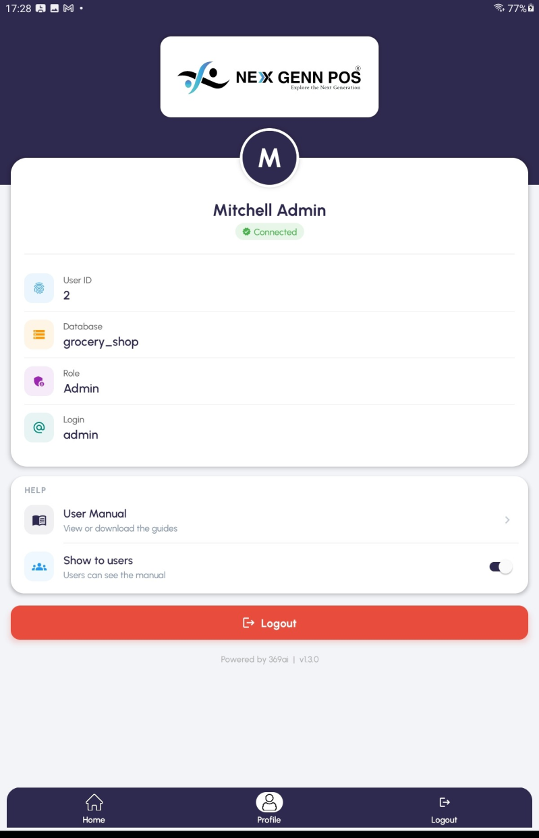
Profile — the HELP card with User Manual and the Show to users switch.

Good to know
- The version number at the very bottom is worth quoting if you ever need to report a problem.
- If the badge says anything other than Connected, your internet or the server is the first thing to check.
- The circle at the top is your own initial rather than a photo — there's nothing to upload.
Logging out
What it's for
Logging out signs you off on this device. The next person sees the login screen and has to use their own details. If you share a device, log out at the end of your shift so the next person's sales are tracked to them, not you.
Step by step
- Tap Logout in the bar at the bottom (or the Logout button on your Profile).
- A box slides up asking if you're sure.
- Tap Yes to sign out — you're back at the login screen.
- Tap Cancel if you tapped it by accident.
Good to know
- Got an unfinished sale? Leave it as a Draft first (back out of the basket) — you'll pick it up from Orders after the next person logs in.
- Logging out changes nothing — every sale, order, expense and customer stays exactly where it was.

